# Multiple Linear Regression

## Overview

* Allows for an outcome to be predicted by taking into multiple predictors with one method
* Allows for predictors to be binary, categorical or continuous
* The ability to predict can be improved by using more than 1 predictor at a time

Basic Structure is a linear equation

Some function of an outcome = intercept + B1X1 + B2X2 …..

f(y:X1…Xp) = B0 + B1 X1 + B2 X2 ….

A function of y, given multiple predictors X1 to XP

There can be up to P predictors but some predictors may be multi categorical and thus will require multiple variables

### Outcomes of interest and the respective regressions

* Continuous outcomes: mean of the outcome y, ybar – ***multiple linear regression***
* For binary outcomes: the lhs is the ln(odds) of the binary outcome (y = 1) i.e. ln(p/1-p) – ***multiple logistic regression***
* Time to event-outcomes:
  + Individual event and censoring times are not known, y = 1 or 0 (yes/no), is an indicator of whether the event occurred in the common follow-up period, lhs is ln(incidence rate) -- ***Poisson Regression***
  + Individual event and censoring times are known, y is a composite outcome taking into account both time and whether the event occurred, the lhs is ln(hazard rate)—***Cox regression (or poisson regression but you need to group it)***

Ultimately, we can only estimate the regression equation from a sample of data so tere will always be hats

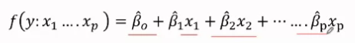

* X1 … can be binary, categorical or continuous
* B^0 is the value when all Xs = 0
* Each slope estimates the difference in the lhs for a one-unit diff in the corresponding x –**but we have to adjust for the presence of all other variables**

Example – multiple regression

f(y:X1 … X5) = B^0 + B^1 X1 + B^2X2 + B^3X3 + B^4 X4  + B^5  X5

predictor:

1st predictor – binary

X1 = Sex (1 = f, 0 = m)

2nd predictor is nominal categorical, 4 cities of residence:

Baltimore, London, delhi, capetown

* Baltimore is the reference
* X2 = 1 for London, = 0 if not london
* X3 = 1 for Delhi, 0 if not Delhi
* X4 = 1 for capetown, 0 if not Capetown

3rd Predictor is age – continuous

X5 = age (years)

Slopes:

B^1 is the difference in value of LHS for females compared to males, adjusted for city and age (of the same city and age)

B^5 is the difference in the value of LHS for subjects who differ by one year in age, adjusted for sex and age

B^2, B^3 and B^4 represent the differencs between London & Blatimore, Delhi & Baltimore, capetown & baltimore, respectively when adjusted for age and sex

Confidence intervals for indiv intercepts and slopes:

B^I +- 2 SE

Hypothesis tests, testing H0: Bi = 0 will e done by computing the standardized distance (no of SE^s) of B^I from 0 and converting it to a p-value

### Joint Null

However, when using **mutli-categorical indicators** (different Cities) for a single predictor (if cities affect the LHS) in a multi variate regression, we cannot look at the P values for each multi-categorical indicator itself. Rather, we must test all of the **indicators of this predictor together** and test all 3 slopes at once. Thus, we must ascertain that

The Joint null i.e. H0 : B2 = B3 = B4 = 0 (which means that there’s no difference between all cities and not just each of the cities with the reference (Baltimore))

* We are checking if the predictor, as a whole, is statistically significant

## Multiple Linear Regression: examples

Data : Height, weight and arm circumference

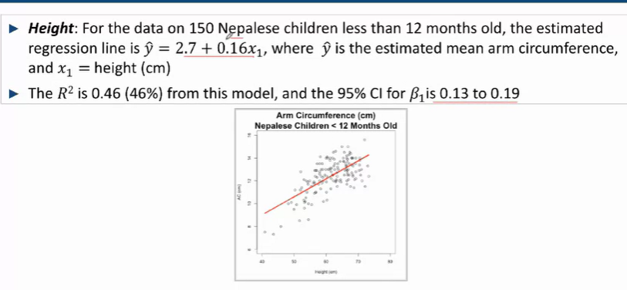

-The Slope, B1 = 0.16, indicates that for every unit rise (cm) in heigh, there is an increase of approximately 0.16 cm in arm-circumference

-The R2 Value of 0.46 (46%) indicates that height, explains about 46% of the variance in arm circumference

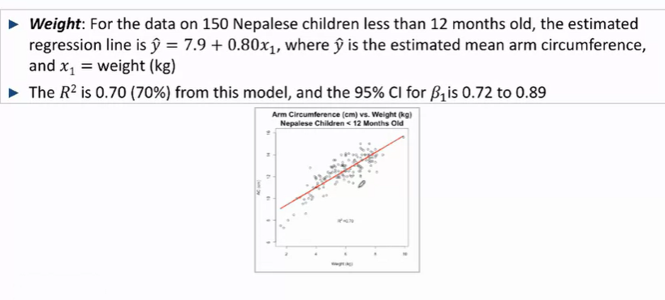

-Height and weight can be related

-Taken together, they may explain variability in arm-circumference more

-There may be confounding

-We fit a multiple linear regression to look at both height and weight

Y^= B^0 + B^1 X1 + B^2 X2

X1 height

X2 weigth

**Results taken together**

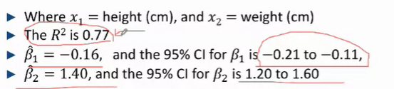

The R2 of the new model, 0.77 > that of both height (0.46) and weight (0.70), but it doesn’t represent a significant increase in R2 as compared to the R2 value of weight (explains more of the variance)~~– this may be an indication that weight accounts for a greater proportion of variability in arm-circumference than height does~~

B^1 , **the weight adjusted association between arm circumference and height** – for individuals of the same weight, groups of children 1cm taller in height will differ in arm circumference, on average, by -0.16cm

95% CI for the true weight adjusted arm circumference and height association, -0.21 to -0.11

B^2, **the height adjusted association between arm circumference and weight** – States that for individuals of the same height, children who are 1kg heavier will, on average, have an arm circumference that is 1.40cm larger

95% CI s 1.20 to 1.6

**Intercept**

B^0 – 14.1 – estimated **mean** arm circumference for children with both heights and weights of 0cm and kg respectively

### Presenting of regression results

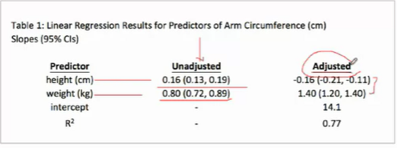

* Adjusted model presents **unadjusted and adjusted** variables + **intercepts + R^2 ( for adjusted)**

**Confounding**

With this, we can see that taking the adjusted vaues for B^1 and B^2, the association of height and arm circumference has changed directions.

Thus, we can conclude that height and weight were confounding factors in the others’ respective relationship with arm circumference

Furthermore, there is a significant upward shift in the adjusted value of the slope for weight, **and their confidence intervals don’t overlap** – which indicates there’s a statistically significant shift in the range of possible values it can take

(though weight confounds height more so than vice versa)

**Could present results from several models side by side**

* Also Include age (multi categorical predictor)
* Notice how age has one p value ( a joint null for all categories of age)

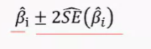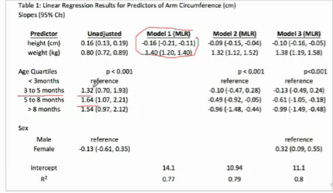

-**unadjusted** – checks the impact of each of the predictors on their own

-**Model 1** adjusting for height or weight

-After adjusting for height and weight, age is still statistically significant (**model 2**) but have a different direction of association (reversal that indicates the presence of variables confounding the effect that age had on ar circumference)

-**Model 3**, adjusting for Heigh weight and age to test the effect of Sex

**Summary**

* Each slopt B^I is the estimated **adjusted mean difference**  in y for 2 groups who differ by one unit in xi **adjusted for all other xs** in the model
* The intercept B^0 is the estimated mean for the group with all xs = 0 (though it may not be a relevant quantity, it is still necessary to specify in the regression equation

## Multiple linear regression: Model estimation, and handling uncertainty in the resulting estimates

### Least squares

Algorithm to estimate the equation of the line is called the “east squares”estimation – find the line t (actually many planes for the diff predictors) that gets “closest” to all the points – to minimize the sum of squares **of differences between the observed values (y) and mean value given by the regression line, given all x’s for that particular observation in the sample**

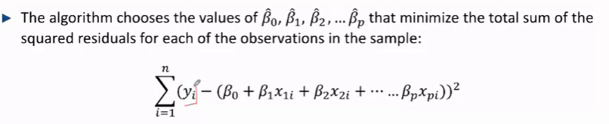

* This method also yields SEs for slope and intercept estimates
* The number of dimensions corresponds to the number of predictors + 1
* The random sampling behaviour of regression slopes and intercepts is normal -- ***in smaller distributions, the 95%CI and p values are based on the t distribution with n- (p+1)degrees of freedom where p is the number of xs in the model***
* 

What do p-values for population slopes tell you?  
it tests whether xiis a statistically significant predictor of y after accounting for all Xs in the model

H0: Bi = 0 HA Bi =/= 0

Assume that the null is true (there is no association)

Example – arm circumference

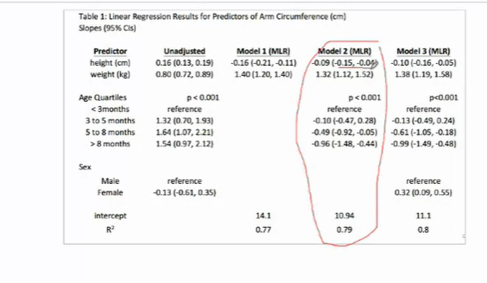

Lookin at Model 2:

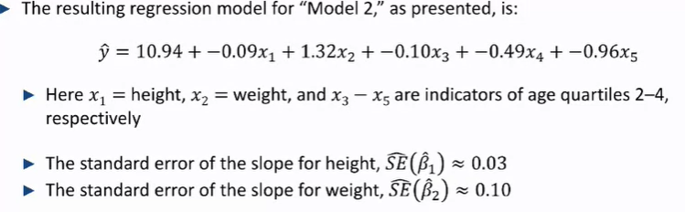

B1 = slope for height = -0.09 ; SE^Height = 0.03 ; 95% CI (-0.15, -0.03) – adjusted for age and weight

B2 = slope for weight = 1.32 ; SE^Weight = 0.10 ; 95% CI (1.12,1.52) – adjusted for height and age

p-value of B1 = B^1 / SE^(B^1) = 0.09 /0.03 = 3 Standard errors 🡪 pvalue < 0.05

**Testing whether multi categorical predictors are statistically significant:**

To test if age is a significant predictor of arm circumference, adjusted for weight and height

H0: B3 = B4  = B5 = 0 (the relationships between age group 1-2, 1-3, 1-4)

HA: at least one of the group differences is 0

### Partial f test

Compares the amount of variability in y explained by weight, height and age to the amount if the variability in y is explained by weight and height only



-The null must be nested in the extended model

H0: all slopes for the extended model = 0

***Does the extended model explain enough extra variability in y compared to the null model to justify having to use 3 more variables to model y for the same amount of data***

### Summary

-Cis for slopes are confidence intervals for adjusted mean differences

-Cis for intercepts are confidence intervals for the mean of y for a specific group (all xs = 0): which is not always relevant, especially when at least some xs are continuous

-Formally testing multi-categorial preditors requires testing 2 or more slopes together – partial F test with a computer

## Estimating group means and mean differences for groups who differ in more than one predictor with multiple linear regression

Example – arm circumference

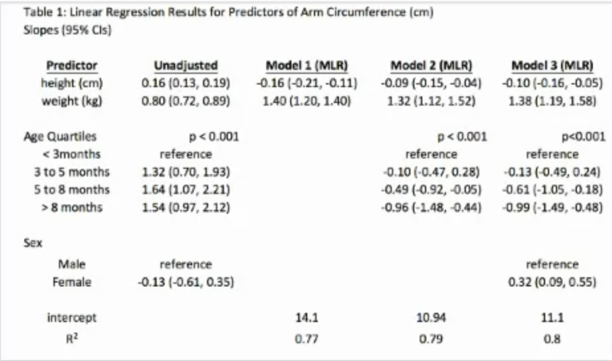

Model 3 – includes 3 predictors

Adjusting for height, weight and age quartiles when needed



-where X3, X4, and X5 represent the mean differences in arm circumference for children in the 2nd, 3rd and 4th age quartiles respectively

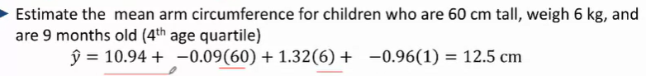

**Groups differing by more than 1 predictor**

E.g. children who are 60cm tall, 6kg, 9 months (4th age quartile) v 45cm tall, 4kg, 6 months (3rd age quartile)

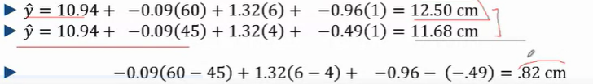

* *The different slopes are additive*

-Cis can be obtained for these quantities though the use of a computer is needed

## Assessing linearity in multiple regression models (continuous predictors) – not concerned with binary and categorical predictors

E.g. Arm Circumference

- a useful visual disaply for assessing the nature of association is a scatterplot – unadjusted height’/AC

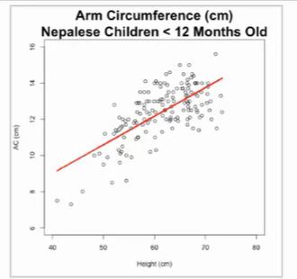

* We can fit this multiple linear regression (MLR) that includes height, age and weight

How do we ascertain in the r/s between height and ac are still linear after adjusting?

### Adjusted scatterplots – unique to linear regression

* Plot of the variability in AC not explained by weight and age against the variability in height not explained by weight and age

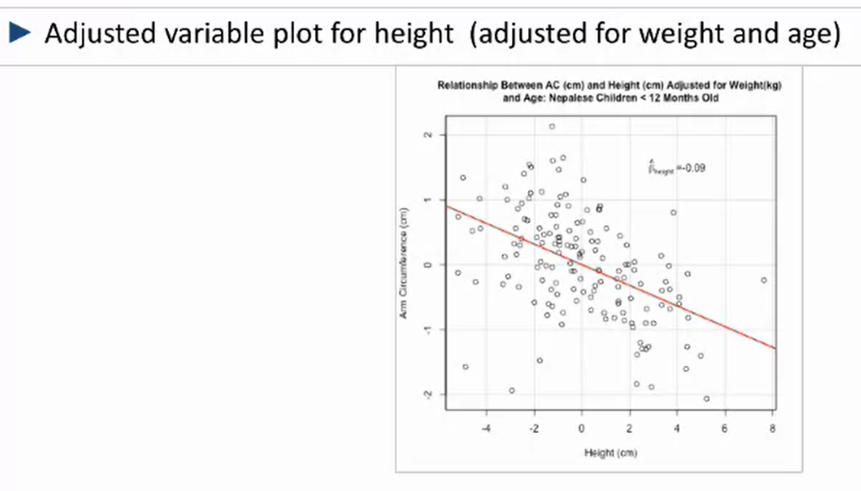

-residuals of arm circumference against the residuals of height (once adjusted for weight and age)

-The slope of the line is the slope of the predictor for height once adjusted for weight and age, X1 B1

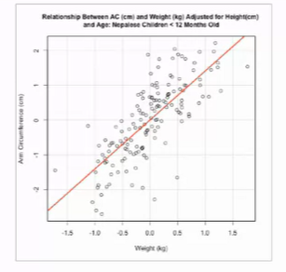For weight against AC, adjusted for height and age

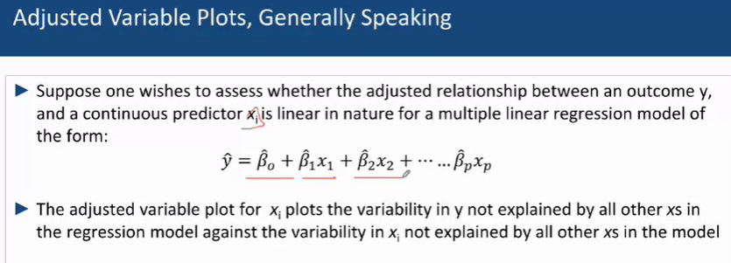

-The adjusted variable plot for xi (any predictor) plots the variability in y not explained by all other Xs (predictors) against the variability in xi not explained by all other Xs in the model

*It is important to assess the linearity relationship*

### 2. Categorise height into quartiles and look at respective slopes

- To see if the change in quartiles is relatively similar between te different quartiles

Example – circumference and height/age/weight

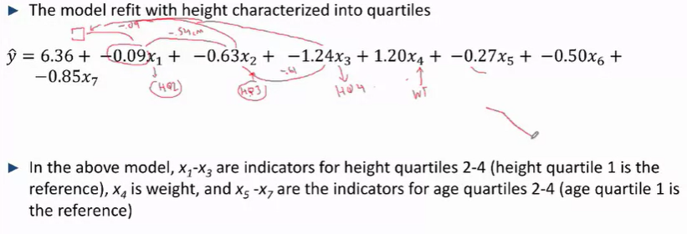

-Differing decrease between height q1 q2, q1 q3, q1 q4

### Spline Approach

* Assume that the association changes differently for different ranges of values –e.g. The arm circumference changes differently wrt height for values of height <60 cm and > 60cm .
* Estimate different slopes for each of these categories – they turn on (=1) when height falls in that range and turn off ( =0) when height doesn’t fall in that range

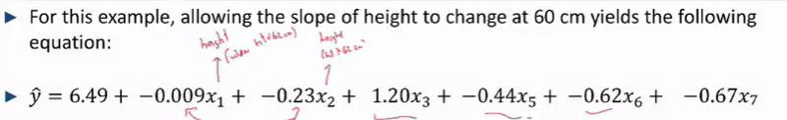

In the above, x1 and x2 correspond to heights <= and > 62cm respectively

### How to choose the final, best linear regression model

Depends on goals:

1. To maximize precision of adjusted estimates 🡪 keep only predictors that are statistically significant in the final model, carrying things that are “Deadweight” will reduce precision and increase SE^
2. To present results comparable to results of similar analyses made previously 🡪 Include similar predictors (at least in one model) even if they aren’t statistically significant in your analysis
3. To show what happens to magnitude of association with diff levels of adjustment 🡪 present the results from several models that include different subsets or combinations of adjustment variables
4. To predict 🡪 ??????????????

Example – arm circumference

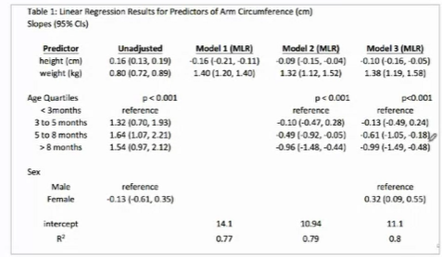

How to assess well a model predicts the variable of interest (and some limitations)

R2 – will increase with additional predictors regardless of whether these add information about the variability in Y; usually reported without CIs

Adjusted R2 -- Recalibrates R2 and only increases for additional predictors that are informative – ***should be reported instead***

-adjusted R2 tends to be lower than its corresponding R2 value if there are **insignificant** independent variables

Prediction is complicated:

(adjusted) R2 evaluated from models fit with the same data, will tend to overestimate prediction – because the model was made for that data

### Choosing a model – cross validation

-To choose a model because it has the best prediction among the estimated modles and to evaluate how ell it predicts for observations not used to fit the model

1. split the data randomly into 2 subseets 🡪 a training and validation set

-Fit and compare the relative prediction abiliteies of models first using the training data, choose a final model 🡪 perform cross validation

-evaluate the prediction of this final model based on how well it predicts for the validation set i.e. use the adjusted R2 to measure how much variation in the outcome the model (made with the training dat) explains observations in the validation data

## Examples of linear regression

e.g. differences in physician salary according to their sex

* Unadjusted annual salary:

Male: 200433

Female: 167 669

-Adjusting for leadership, seniority etc. the difference was reduced to ~13k but was still statistically significant

-Most characteristics were categorical

Results:

Initial model: all indicators are included regardless of if they’re significant or not

Final model: non significant predictors are removed

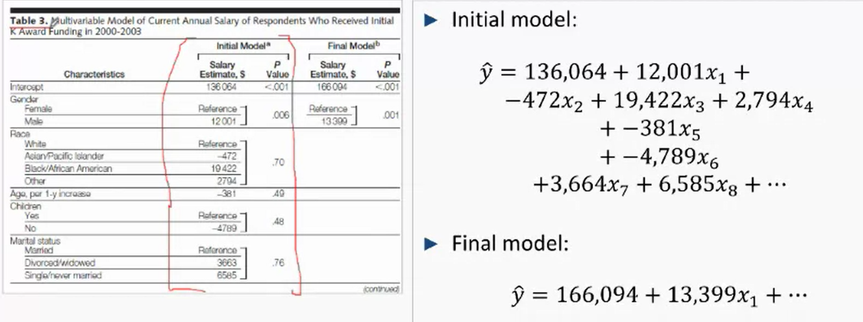

* Pvalue derived from partial R test
* Final v initial model: the only predictor that is kept from start to end is Sex
  + The rest, race (between white, Asian, black, other), age, children and marital status were all deemed non statistically significant – p-value .48 to 0.76

## Investigating Effect Modification with Multiple Linear Regression

-To investigate effect modification, one needs to see separate estimates of an outcome that expose a relationship for different levels of an outcome. Not one overall adjusted r/s but multiple separate relationships

-Formal test of whether there’s effect modification or not

-Effect modification is a 2 way street:

- If sex (X) modifies te Rs between mortality (y) and treatment (z), then treatment(z) modifies the rs between mortality (y) and sex too (X)

-***easiest to interpret when at least 1 of the 2 pieces is binary or categorical***

-effect modification can be assessed when pieces are continiuous, but it is “messy” to interpret

### Option 1: Stratifying data into different subsets

* Based on each level of one of the variables involved and estimate separate regressions of each subset 🡪 e.g. investigating how sex affects the r/s between treatment and death
  + Stratify the groups by sex (m/f) and investigate the relationship between placebo and the test drug from there to check if there are any differences in their regressions
* Compare the estimated slopes for each predictor across the different subsets (adjusting for different factors like age etc.)
* ***This is a good option if the researcher is concerned that one measure (the stratifying variable) modifies all outcome predictor relationships***

Example – arm circumference, sex and height

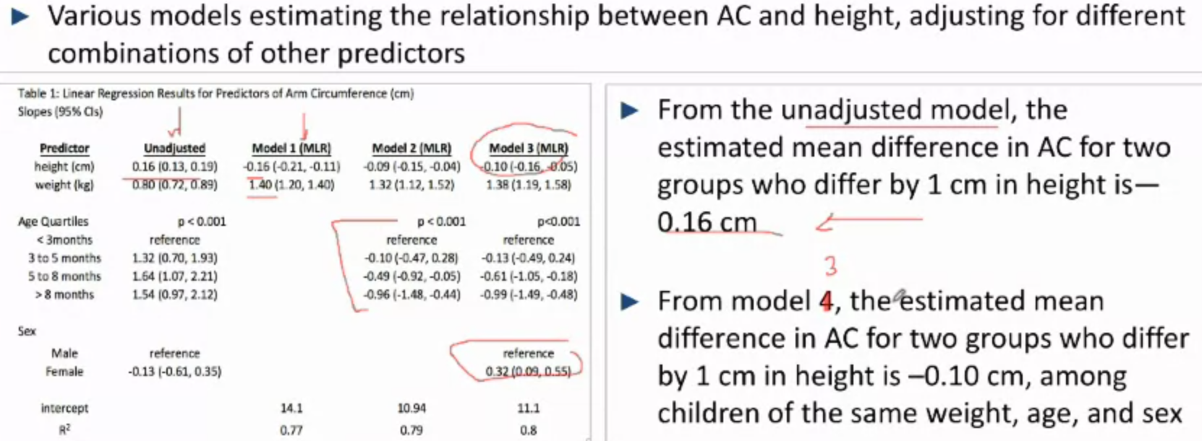

* In model 3, the slope of -0.10 estimates the AC/height association for children (adjusted for sex, age and weight) but it doesn’t allow us to investigate how the AC/height association for children, controlled for age and weight, differs for the 2 sexes

Split the data by Males and females

* Estimate separate regressions
* Compare their slopes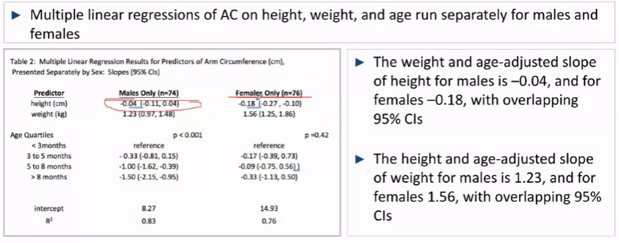

**However, the 95% Cis for the slopes of height overlap. So, we can’t test if they’re different**

* Looking at the p-values, we realise that age is statistically significant for only males but not for females. However, this may be a result of the small sample size. And, especially as the slopes for height for males and females have overlapping 95% Cis, this may be a shortcoming of the study and they may not be significantly different.

### Option 2: Introducing an Interaction term

* Between the main exposure of interest in terms of effect modification – and its potential effect modifier
* Run a regression that includes the exposure of interest, the potential effect modifier, the interaction term, and all other predictors of interest
* This allows for an assessment of a specific effect modification of interest while using all of the data to estimate other (adjusted) outcome exposure r/s
* ***Allows for a formal (hypothesis) statistical test of effect modification***

E.g. Arm circumference, height and sex – confounding and effect modification

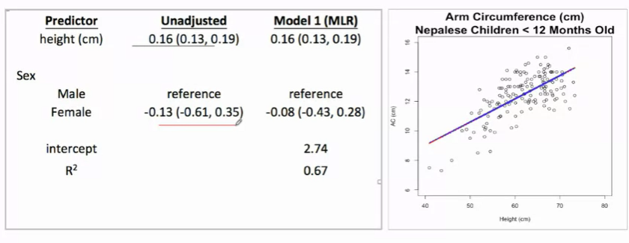

-Adjusting doesn’t change the slope for height but changes it for sex

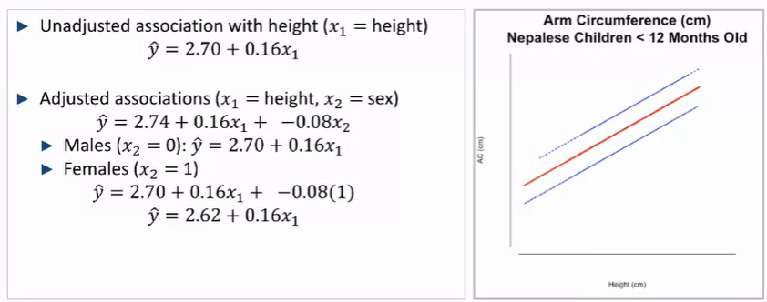

-Red line – unadjusted

-Blue lines – males and females (the difference between the 2 parallel lines is given by the slope – for the same height, females have an AC that is on average lower by 0.08 cm

**How do estimate sex-specific associations between slopes** (AC and height)

* We are going to introduce an interaction variable, that is a combination of the interaction between the variables (in this case, sex and height)
* 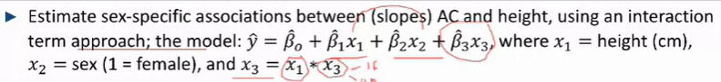

** Correction X3 = X1 x X2 🡪 thus when X2 = 0, x3 is non-existent i.e. it gets “turned on and off” 🡪 modified by the slope, B^3 ,that quantifies the difference between the 2 genders

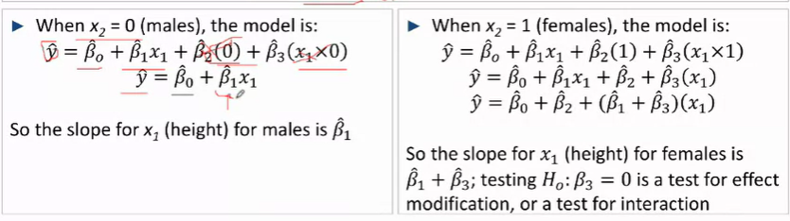

-the slope of height for X1 differs based on the presence of the interaction term 🡪 if there were no difference (**i.e. effect modification**) we’d expect the males and females to have the same slope

-Thus, we can perform the hypothesis test to check if B^1 = B^1 + B^3 🡪 Thus H0 : B3 = 0

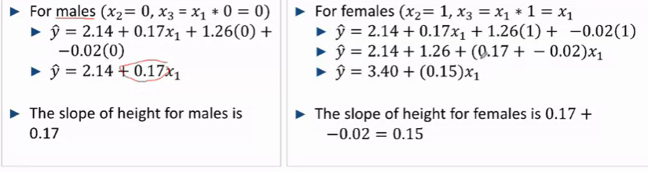

B^1 = 0.17; B^1 + B^3 = 0.15

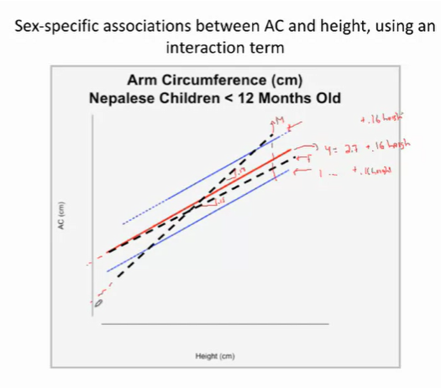

-Due to the differences in slopes, the 2 equations have different intersects too

-the relationship between AC and height differs for males and females at different heights

## Centering continuous predictor (s) in multiple linear regression

e.g. AC, weight, height and age

- gives the intercept useful scientific interpretations

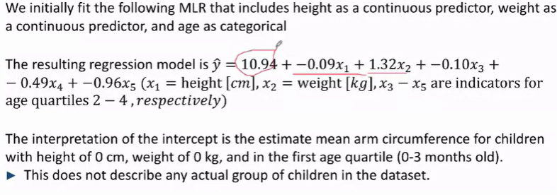

* Here the initial intercept corresponds to when all continuous variables (height and weight) = 0 and of babies falling into the first age quartile (0-3mths old) 🡪 **which doesn’t describe any actual group of children in the dataset**
* We can adjust it to make it useful, we can centre it around a point
* We do this by subtracting a set value from both X1  and X2

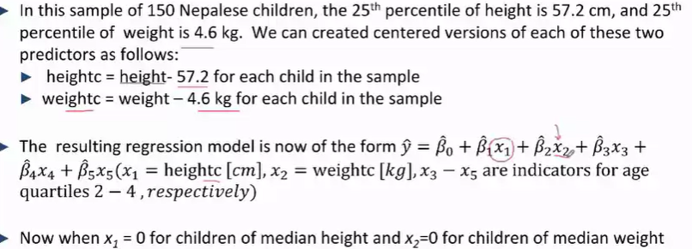

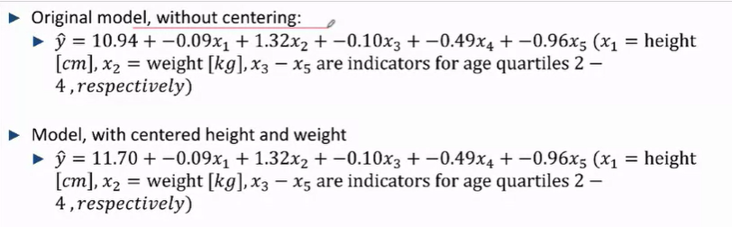

-With the new model, only the intercept changes 🡪it is the estimated average arm circumference for children in the lowest age quartile with 25th percentile values for height and weight 🡪 gives a value that exists in the dataset that is physically significant

-you must remember to calculate this new intercept yourself (taking values of ac for 25th percentile values for height and weight, in the lowest age quartile)

-you must remember to subtract 57.2 cm and 4.6 kg from values plugged into X1 and X2 respectively

# Multiple Logistic Regression

* Slope: ln(OR^) estimates the increase in ln (odds ratio) for, either, an unit increase of a continuous predictor. Or the presence of a categorical variable as compared to the reference group
* Intercept: estimates the ln(Odds) of the outcome of interest = 1 (happening), given that all predictors (categorical or continuous ) = 0 – this value may not be scientifically significant especially when there are continuous variables
* Exponentiated Slope: e^(ln(OR^)) estimates the odds ratio corresponding to an unit increase in a continuous variable (when comparing the higher to lower continuous variable); or the odds ratio of the event of interest happening when the categorical/binary predictor of interest is present (=1) as compared to the reference group
* Exponentiated intercept: the odds of the outcome of interest = 1 (happening), when all Xs (predictors) = 0

E.g. Obesity, biological sex and HDL levels

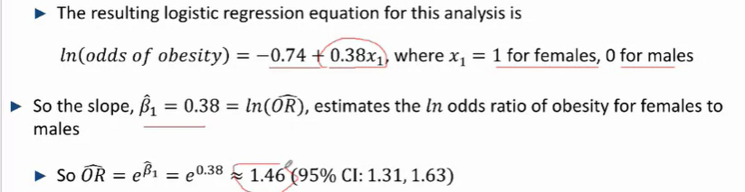

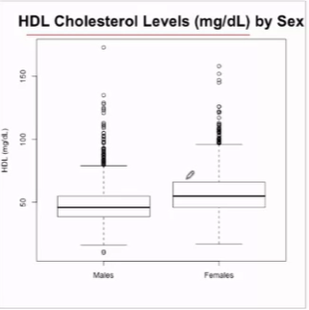

-Mean difference of HDL between male and females are statistically significant

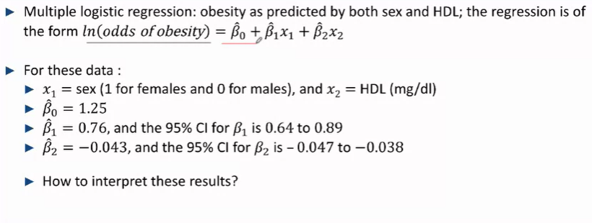

B^1, slope is an estimate for the ln(odds ratio of sex) = 0.76

Estimated odds ratio of sex for obesity = e^0.76 = 2.15 – **HDL adjusted association between Sex and Obesity**

* Thus, the odds of obesity for females is 2.15 times that the odds of obesity for males when adjusted for HDL levels

B^2, the slope is an estimate for the ln( odds ratio of obesity) for 2 groups of individuals differing by 1 unit of HDL, of the same sex

Estimated odds ratio of (an unit increase in) HDL on obesity = e^-0.043 = 0.958 – **Sex adjusted association between obesity and HDL**

* The odds ratio of being obese for 2 groups of individuals who differ by one mg/dL in HDL levels is 0.958, higher to lower HDL, for those of the same sex

B^0, intercept, is the estimated ln(odds of obesity) when all Xs in our equation = 0

* When male and HDL levels = 0
* e^(B^0) = estimated odds of obesity for a male who has HDL levels of 0 mg/dL
* Not particularly scientifically relevant

## Adjusted Odds ratio

* Adjusting for other factors to determine the odds of something happening when the extra individuals, that may be skewing results, have been eliminated
* Unadjusted v Adjusted:  
  - Unadjusted: how the odds of the result of interest change when there is a change in the predictor of interest

- Adjusted: how the odds of the result of interest change when there is a change in the predictor of interest provided that (some/all) other variables of interest are controlled for

Example – Neplaese Children and Breastfeeding

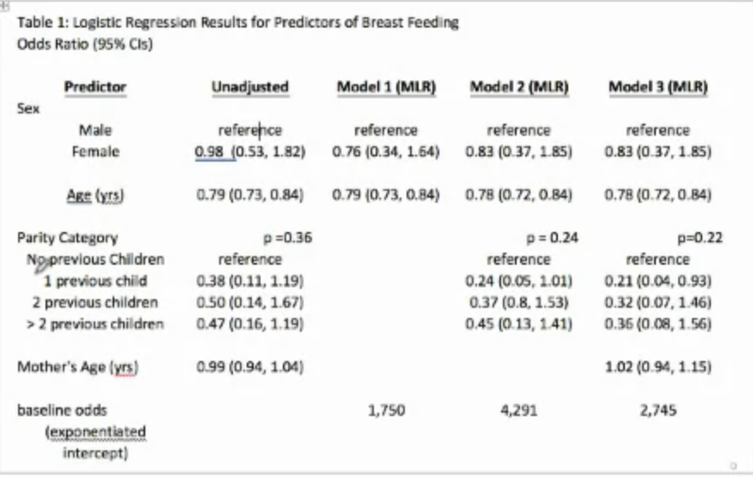

* Unadjusted
  + Mother’s age was not statistically significant
  + Parity category was not statistically significant either
* Model 1 – adjusted for Sex / Age
  + Increases in age exhibit a similar OR for when not adjusted by sex, indicating that sex wasn’t a confounding factor for odds of being breastfed with age
* Model 2 – adjusted for Sex + Age / Sex + Children / Children + Age
* Model 3 – adjusted for Sex, age, mother’s age, children etc etc. permutated

Baseline odds – describes different groups in different models

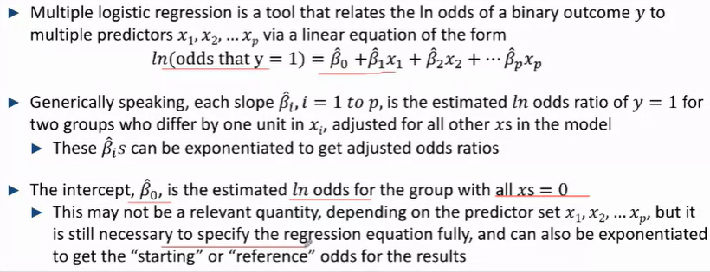

### Model Estimation, and handling uncertainty

Estimating:

“maximum likelihood” method: the estimates for the intercept (B^0) and slopes are the values that make the observed data “most” likely among all slopes and intercepts

-Also provide standard errors for intercept and slopes 🡪 which allow for the computation of the 95% Cis and P-values for the slopes and intercept

-Results (ln odds) and ln(OR)s will be exponentiated to present the results as Odds or Ors

95% CI = B^ +- 2SE^(B^)

For both odds and intercepts

**p-values for slopes**

tests whether Xi is a statistically significant predictor of y after accounting for the other xs in the model

H0: Bi = 0 vs Ha: Bi =/= 0

t or z or p = B^I / SE^(B^i)

Example – obesity

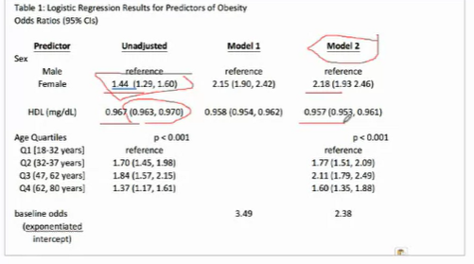

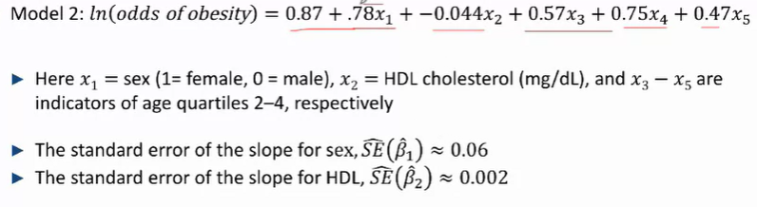

**Obesity and sex**

95% CI for B^1= 0.78 +- 2(0.06) 🡪 (0.66, 0.90)

95% CI for the adjusted OR

e^(B^1) = e^0.78 = 2.18 🡪 (e ^0.66, e^0.90) = (1.93, 2.46)

**Obesity and cholesterol**

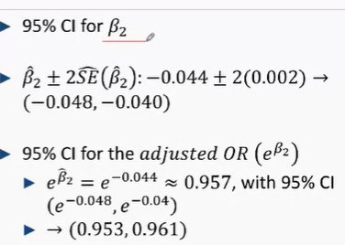

-Null values for ln(OR) = 0, for OR = 1

**P -value for population slope B1** : To test sex is a statistically significant predictor of AC after accounting for HDL and age

Assuming the null is true, *the slope is 0*

Z = B^1 / SE^( B^1) = 0.78 /0.063 = 12.4 🡪 p < 0.01

**Presenting different models**

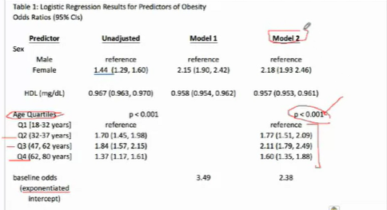

* Model 2, adjusts for sex/hdl levels/age (quartiles)

### Testing multi-categorical variables in a multiple logistic regression – likelihood ratio test

* H0: B3 = B4 = B5  = 0
* Ha: B3 = B4 = B5  =/= 0

likelihood ratio test: compare the amount of information in y explained by sex HDL, and age to the amount of info in y explained by sex and HDL only

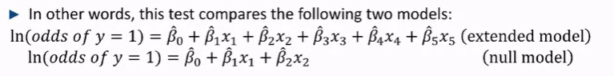

* It tests if the extended model adds enough additional information about the outcome, then H0 is rejected; else, the null model is preferred
* Extended model includes everything that is the null model + additional predictors (the null model is nested within this)
* The likelihood ratio test is not only limited to multiple categorical predictors

## Estimating odds and proportions in multiple linear regressions

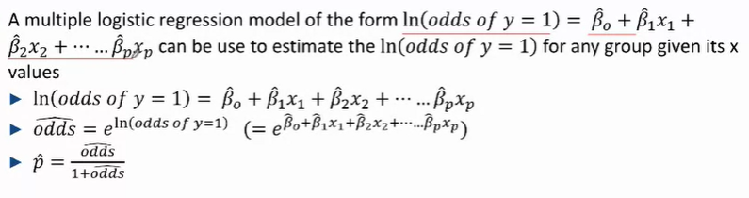



-Where X1 Represents sex (female = 1), X2 represents HDL levels, X3-X5 (represent the individual being in the 2nd to 4th age quartiles)

to estimate the proportion nof obese adult females with :  
 1. HDL = 75mg/dL

1. 65 y/o (in the 4th age quartile)

Ln(odds of obesity) = 0.87 + 0.78(1) + (-0.044)(75) + 0.47(1) = -1.18



We can determine the proportion of individuals, of a very specific characteristic, who will face a certain outcome (in this case, for females in the 4th age quartile who have HDL levels of 75 mg/dL

### Calculating things in the exponentiated formats – from published formats

Given that Ln(odds of y =1) = Ln(oddsbase) + B^1ln(OR^1) + B^2ln(OR^2)……

Where Ln(oddsbase) + B^1ln(OR^1) + B^2ln(OR^2)…… = a, b, c … respectively

Odds of y=1 = e^(a + b + c…) = e^(a) * e^(b) * e^(c) ……

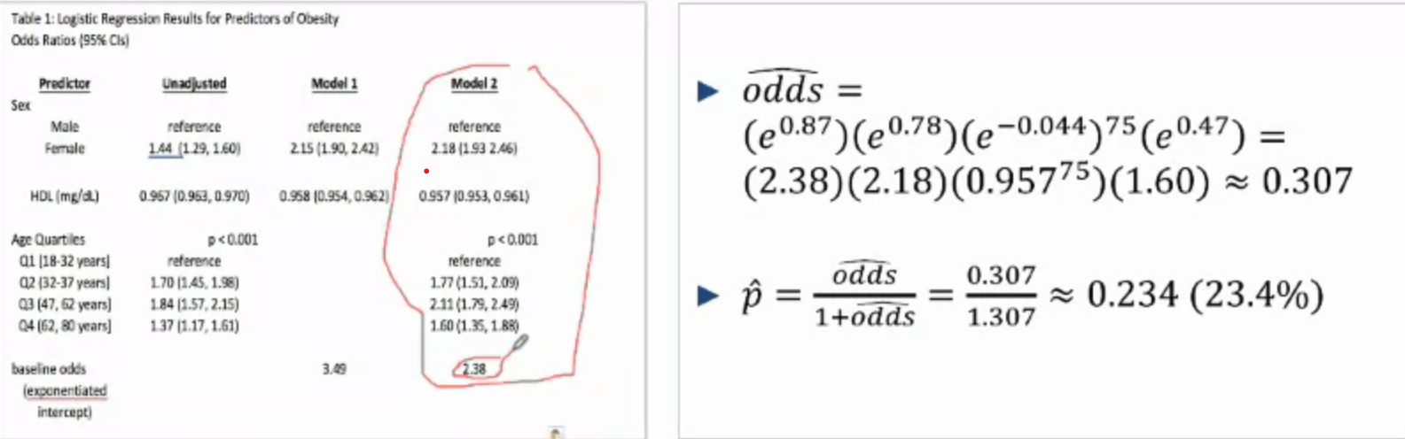

* By taking the adjusted ORs and multiplying them accordingly, we can determine the odds of an event happening (of a specific characteristic) and its corresponding proportion

### Presenting Proportions – graphic

-Shows absolute changes that translate from the odds ratios published

- For males and females, across the 4 age quartiles respectively

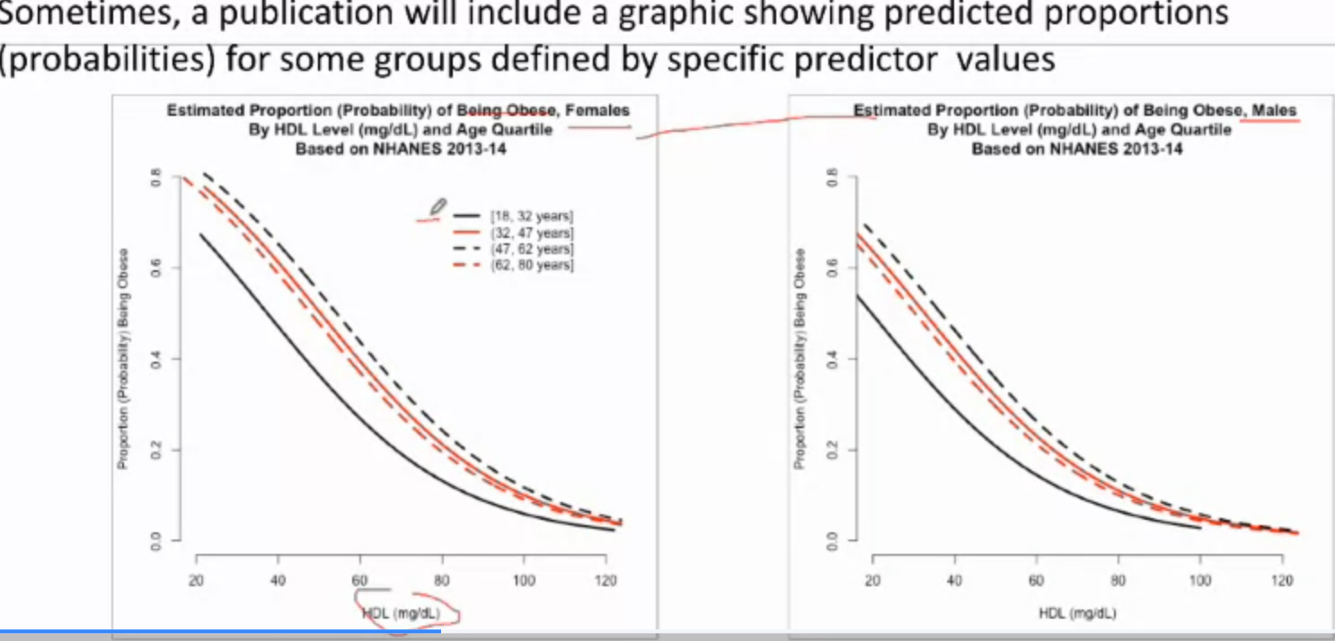

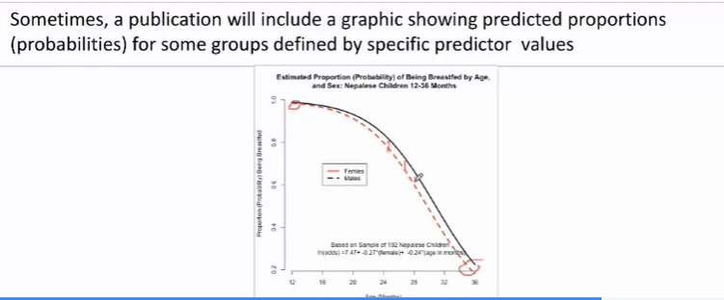

* Presenting the odds of getting breastfed for males and females with age – note how their lines diverge even though their adjusted ORs remain constant across time

### Comparing Odds ratios of 2 groups of distinct characteristics

e.g.

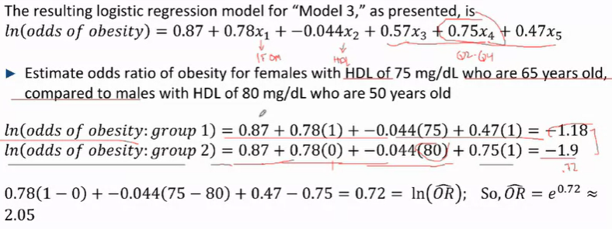

* Females with hdl 75, 65 y/o against – (1)
* Males with hdl 80, 50 y/o – (2)

OR^((1) to (2)) : Ln (odds (1)) - Ln (odds (2)) = ln (odds(1)/odds(2))

OR^ = e^ln(odds(1)/odds(2))

= e^(a1)*e^(b1)*e^(c1)…./ e^(a2)*e^(b2)*e^(c2)….

Where Ln(oddsbase) + B^1ln(OR^1) + B^2ln(OR^2)…… = a, b, c … respectively; and the subscripts of a, b and c denote the group (1) or (2) they belong to respectively

**Summary**

- The results from multiple logistic regression can be used to estimate odds ratios for groups who differ by one or more predictor on both the adjusted odds ratio scales and ln scales 🡪 provided that the **intercept or exponentiated intercept is provided**

-Cis can be computed for the odds ratios of groups that differ by one or more predictor but these must be handled by the computer

## The Linearity Assumption and prediction – determining quartiles,quintiles etcetc or thresholds

* **A problem for continuos predictors, it is not an issue to be concerned with binary or categorical predictors**

Example cholesterol and obesity

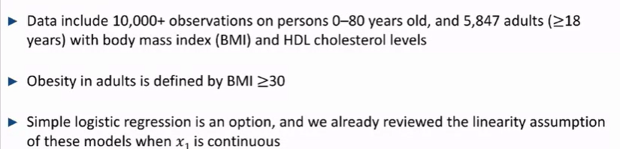

Simple linear Regression:  
ln(odds of obesity)= B^0 + B^1x1

This assumes that the ln(odds of obesity) are linear with HDL levels

This can be assessed with the **LOWESS smoothing plot**

-Gives an empirical visual estimate of the relationship between HDL and log odds

**Linearity assumption in a multiple logistic regression with multiple variables**

* Assumption: is that the relationship between the ln odds of something happening and HDL is linear in nature, after adjusting for sex and age (categorical)

i.e. if the relationship between ln(odds y=1) and the predictor of interest is linear in nature when all other variables are adjusted for – to check if the adjusted relationship is linear in nature

**There is no equivalent to the LOWESS smoothing plot for multiple logistic regression**

* An empirical way to check this is
* Categorising the predictor of interest into (quartiles, or clinically significant thresholds) and determining whether there is a constant change in ln odds

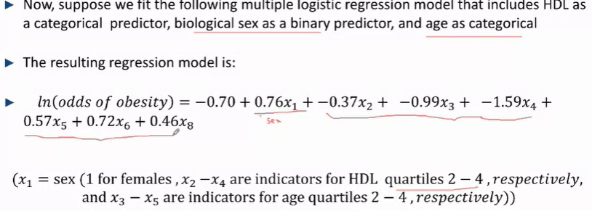

Investigating X2 – X4:

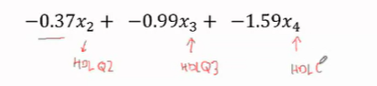

X2: difference in log odds for those in HDL q2 v q1

X3: difference in log odds for those in HDL q3 v q1

X4: difference in log odds for those in HDL q4 v q1

Intervals: x1 – x2 – x3 – x4

(-0.37) – (-0.62) – (-0.60 )

While they don’t show a perfectly linear r/s going from quartile to quartile, as it is constantly decreasing (and of similar magnitudes) they indicate that it is acceptable to indicate this r/s as linear

***In general, the predictor of interest should show a relatively constant relationship as we progress through ordinal categories (i.e. a constant decrease from one category to the next …)***

## Choosing a final multiple regression model

-depends on the goal of research

1. to maximise precision of adjusted estimates: keep only predictors that are statistically significant in the final model

2. to present results comparable to results of similar analyses presented by other researchers (on similar or different populations): present at least **one model (you can present many)** that includes the same predictor set as the other reseatch

3. to show what happens to the magnitude of association with different levels of adjustment:

Present the results from several models that include diff subsets to explore different combinations

### Predicting outcomes with our multiple logistic regression – Receiver Operating Curve

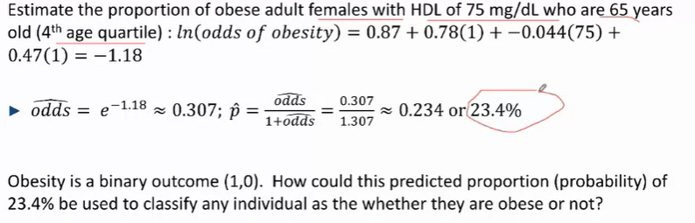

* The odds of being obese for a certain group (with particular characteristics) is 23.4%

If obesity is binary (1,0) how could this predicted proportion (probability) of 23.4% be used to classify any individual as obese or not?? 🡪 basically the probability cannot be translated into a binary variable of yes/no

* No logical way to quantify the variability of a binary outcome explained – there is no R ^2 for a logistic regression (though Pseudo R2 does exist)
* To evaluate how well the results of a logistic regression model predict at the individual level, we need to establish a cut-off to predict the outcome as yes or no
* Set a cut-off of e.g. 23.4% and apply this to everyone in the dataset
  + Anyone above 23.4% probability (according to the model) is obese
  + Anyone who has a predicted probability < 23.4% probability isn’t obese
* However, the issue is that the range of probabilities predicted by the model range from 1 to 81% and any of these levels can, arbitrarily, be set as the threshold for obesity

-Balancing different thresholds

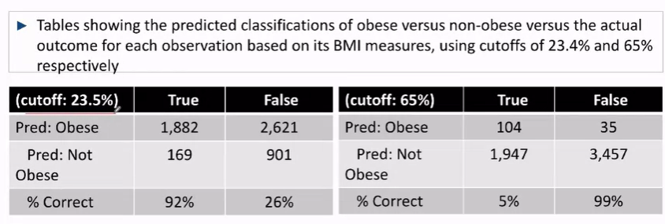

True: refers to those who are obese – according to the data

False: refers to those who are not obese – according to the data

23.5%

We identify those who are truly obese as obese 92% of the time (true positive)

We identify those who truly aren’t obese as not obese 26% of the time; or those who aren’t truly obese as obese 74% of the time (high false negative)

65%

We identify those who are truly positive as obese 5% of the time (high false negative)

We identify those who truly aren’t obese as not obese 99% of the time (high true negatives)

***A good predictor should have a threshold that is able to maximise true positives and true negatives, while minimising false +ves and -ves***

* Proportion of predictions that are correct:
  + Sensitivity: proportion of true outcomes classified correctly by prediction (true positives)
  + Specificity: proportion of true non-outcome classified correctly by prediction (true negatives)
* We can view the sensitivity and specificity for all possible thresholds using a Receiver-Operating Curve (ROC)
  + Plots sensitivity v specificity for all possible prediction cutoffs applied to the results from a logistic regression model to a **corresponding data set**, where the **binary outcome (y) of interest is known for each individual in the data set**

E.g. ROC for obesity, sex, HDL and age as predictors

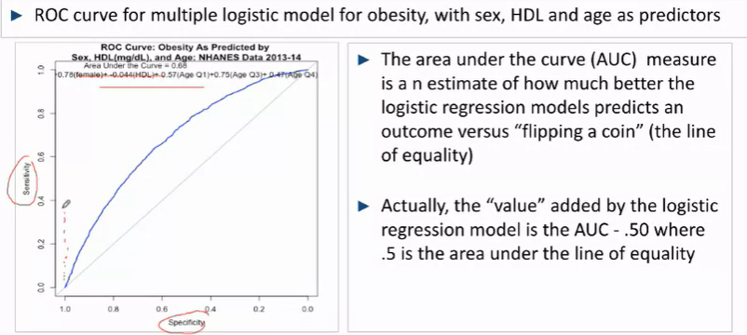

* The variable of interest is the area under the curve (AUC), area under the curve – are under the straight line (that represents flipping a coin)
* We should aim to maximise the AUC

### Ensuring the validity of a predictive model

* One should refrain from using the same data as the model was trained on to validate it
* We should split the data randomly into 2 sets, one for training and one for testing
* Then, develop multiple models and test them against the testing data to evaluate how well they fit the validation data set

## Examples from the Literature

e.g.1:

- to study how the disparities in clinical outcomes diffrs among black and white surgical patients and if they’ve narrowed over time

- Examined trends in thirty-day postoperative mortality rates (for 5 high risk and 3 low risk procedures)

-comparing medicare data from 2005 to 2014

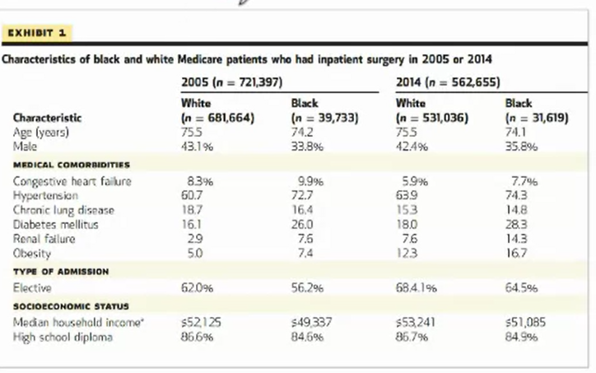

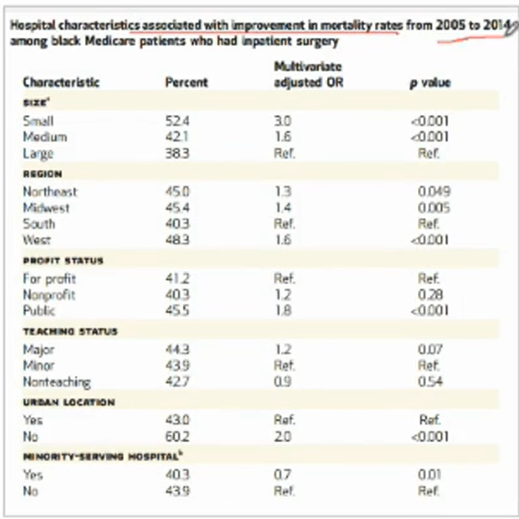

* Examining the log(odds of improvement in mortality rate) for **black** patients, from **2005 to 2014**
* ** no exponentiated intercept – so you can’t use the values to predict a hospital’s mortality given its characteristics

**Size**

Small and medium hospitals experienced 200% greater and 60% greater odds of their black patients experiencing improvements in mortality rates from 2005 to 2014 as compared to large hospitals in the same time period, respectively. When adjusting for regional, profit teaching, urban location nand minority serving status.

## Effect Modification with Multi-Logistic regression

Effect modification is a 2 way street:  
if Z modifies the r/s between y and x

X modifies the rs /between Y and Z

-e.g. sex might modify the r/s between mortality and treatment, then treatment modifies the r/s between mortality and sex – we may want to implement different treatments for different sexes

But the baseline is that it is something that is not changeable and cannot be corrected for unlike confounding. Thus, researchers must take it into account when studying the effects of a predictor on something else

* It may be of scientific interest too
* i.e examining how treatment affects different genders differently allows scientists to determine how to treat individuals of each sex

Effect modification results can be assessed when:

1. a modifier is binary – compare 2 or more categories adjusted for everything else
2. a modifier is continuous – segment the slopes of the modifier and compare the slopes for each range

### Option 1 – split the data into subsets

Split the data into different subsets, based on each level of one of the variables involved (sex, ethnicity etc.) and estimate separate regression on each subset 🡪 good for if we’re concerned with only 1 measure modifying the outcome of all predictor relationships

e.g. Suicide in pacific islanders

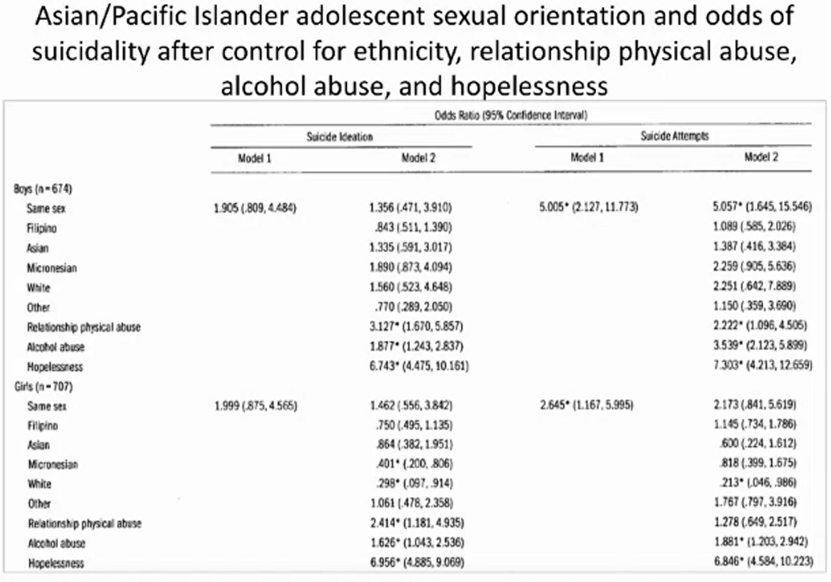

Unadjusted

* to examine the impact of self-identified homosexuality on suicide ideation and attempts

Adjusted – model 2

* Examining the impact of homosexuality and other factors suc has race and vices (adjusted for everything else) on suicide

** Stratified for boys and girls

* They wanted to compare the oods of suicide between homosexual boys and homosexual girls

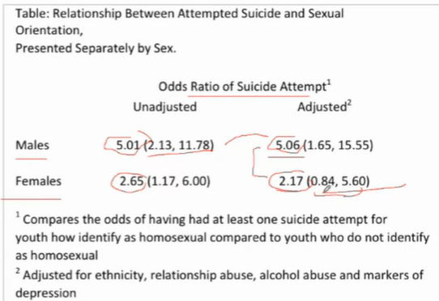

* The magnitude of the odds for suicide attempts are much larger for boys than girls 🡪 **what can we make of this**

### Option 2 – create an interaction term

* Run a regression that includes the exposure of interest, the potential effect modifier and the interaction term – **create an interaction term for each predictor we want to stratify by**
* In essence, if we want to parse out the effect that X has on Y, we stratify by X and we quantify the discrepancies it has on Y for each stratum through the interaction term

e.g. obesity and HDL

2 predictors, obesity in odds regressed on **HDL and age(four categories) – only 2 categories**

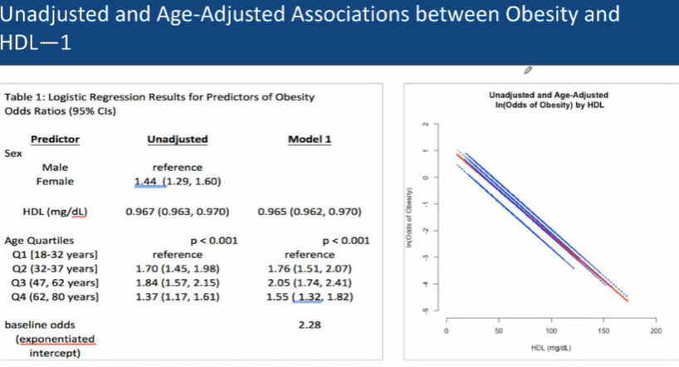

-after adjusting for age (model 1), the odds ratios of hdl on obesity do not change muc and remain statistically significant, indicating that age wasn’t a confounder of HDL

-after adjusting for HDL (model 1), the odds ratios of age on obesity do not change significantly

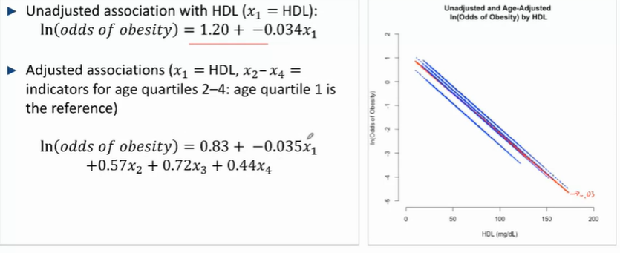

**Age-adjusted ln (odds of obesity) by HDL**

WHERE x1 IS HDL LEVEL AND X2 – C4 CORRESPOND TO AGE QUARTILES 2-4

**Adding an interaction term**

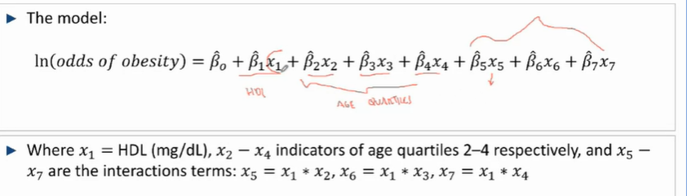

** the interaction term serves to modify HDL, its slope quantifies the difference in the obesity/HDL association for Age Q2 v Age Q1

Where:

B1X1 correspond to the adjusted Slope and units of HDL respectively

B2X2 to B4X4 correspond to the adjusted slope and binary predictors for age quartiles 2- 4 (with reference to age quartile 1) respectively

B5X5 to B7X7 represent the slope for the adjustment terms (in this case for each age quartile) and their corresponding (X1 * X2 to 4)(=1 ,if subject if is of that age quartile and 0 if not)

-For the reference age group (age quartile 1) X2 to X7 = 0

Ln(odds of obesity) = B^0 + B ^1* X1

Example for age quartile 2 – X5 is turned on

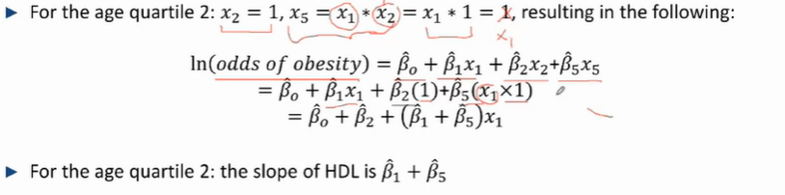

Where X5 = X1*X2 (but X2 = 1) 🡪 thus it factorises out to B^5*X1 = B^5 * HDL levels

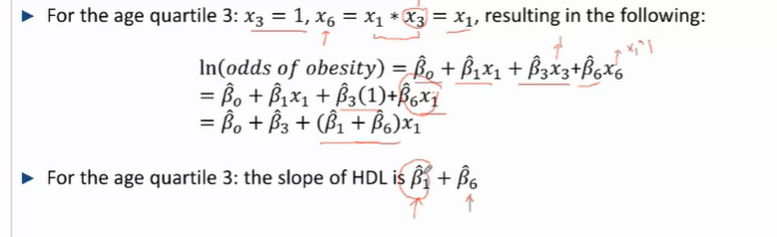

Where X6 = X1 * X3 (but X3 =1) 🡪 thus it factorises out to B^6 *X1 = B^6 * HDL levels

***In essence, the interaction terms quantify how HDL changes specifically for each age group and “modifies” the slope of HDL accordingly***

**Adding numerical results**

- 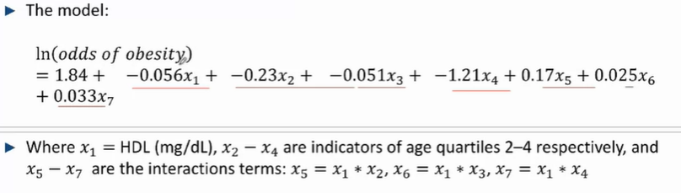

- so for age q 1, the slope is HDL -0.056 ln (OR) of ibesity for 2 groups who differ by 1 mg/dL of HDL for those in the first age quartile

For age quartile 2, X2 = 1:  
ln(odds of obesity) = 1.84 + (-0.056)X1 + (-0.23)X2 + 0.17(X5)

=1.84 + (-0.056)X1 + (-0.23)X2 + 0.17(X2*X1) = 1.84 + (-0.056)X1 + (-0.23)X2 + 0.17(1*X1)

=1.84 + (-0.056)X1 + (-0.23)X2 + 0.17 (X1) = 1.84 + (0.17 – 0.056) X1 + (-0.23)X2

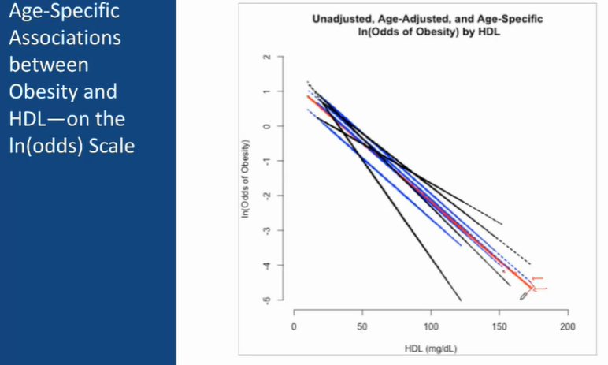

* Black: takes adjustement effects into account
* Blue: only splits them by age groups

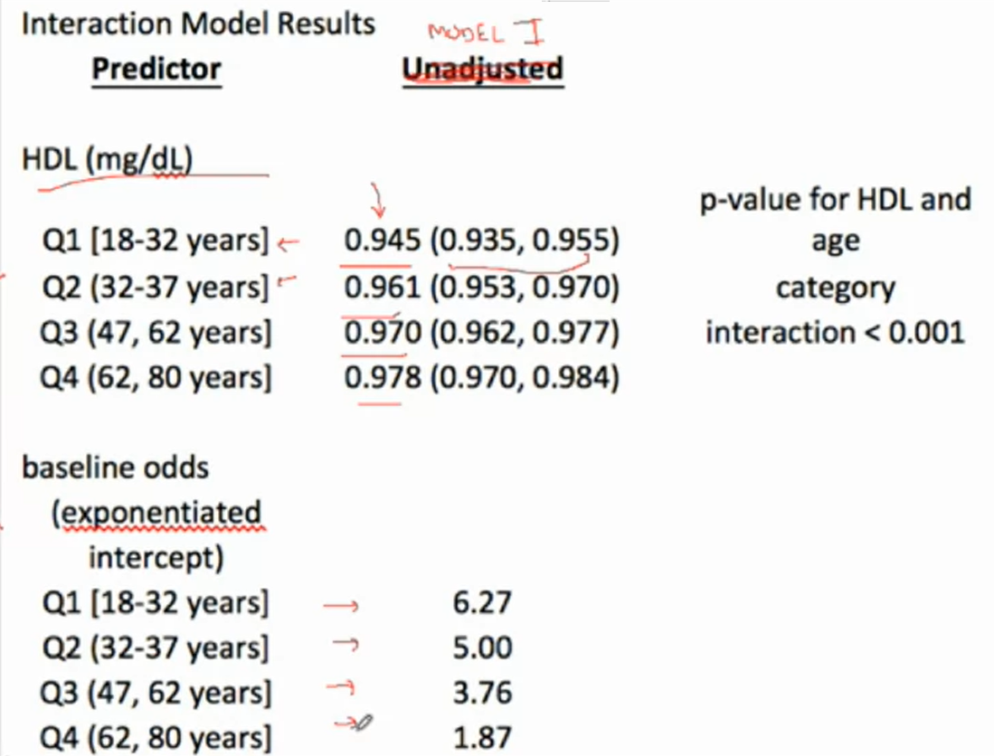

* Baseline odds exponentiated, refer to the exponent of the intercepts of the black lines
* The slopes for each interaction term are 0.961, 0.970, 0.978…
* Formal test, to test for effect modification, would be H0: B5 = B6 = B7 (to test if the modifiers are significantly different), to get the p value

### Summary – investigating effect modification with multiple logistic regression

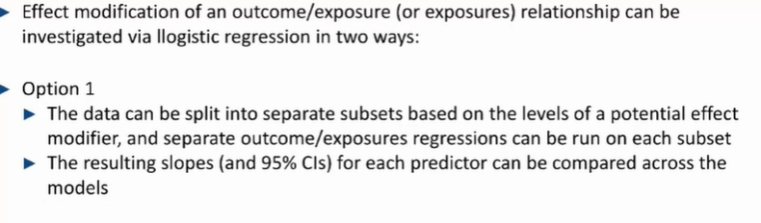

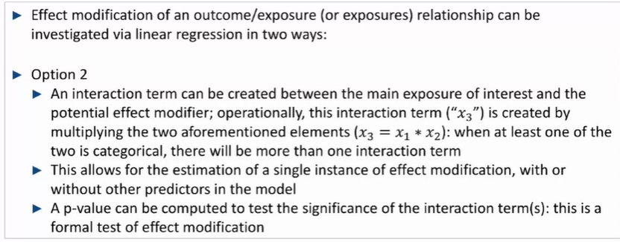

### Additional Examples

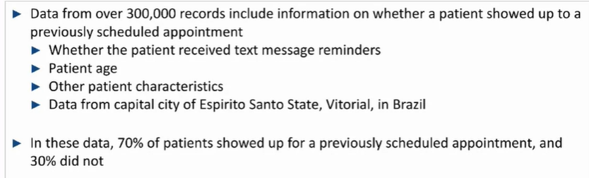

* Simple and multiple logistic regression used to estimate the unadjusted and adjusted associations between appointment attendance and potential predictors
* All who provided a phone number received a text

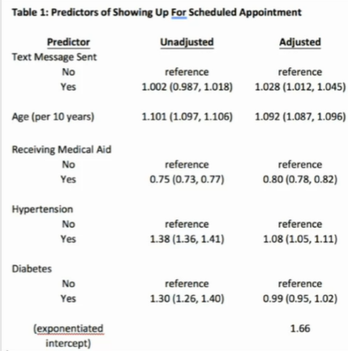  
**Unadjusted**

* Text message sent (yes) – not statistically significant
* Every increase in age of 10 years resulted in greater odds of showing up for one’s scheduled appointment

**Adjusted**

* There is a 2.8% increase in the odds (that was statistically significant) if one received a text message
* While the presence of Hypertension still resulted in an increase in the odds of one showing up for their scheduled appointment – once adjusted for text messages, age, medical aid and diabetes – this increase in the odds decreased from 38% to 8%, signifying that there may have been other factors confounding the relationship between hypertension and the odds of showing up for an appt

**For a simple logistic model with age,**

**Exponentiated intercept = 1.62**

* Exponentiated slope, unadjusted OR = 1.10
* Odds = 1.62 * 1.10^(x1)

For an individual who is 70 years old, odds = 1.62 * 1.1^7 = 3.15; p^ = 3.15/3.15+1 = 0.76

**Adjusted**

70 y/o

* Hypertension
* Text reminder
* No medical aid

V

40y/o

* W/o hypertension
* Who did not receive a text
* Medical aid

Adjusted for diabetes

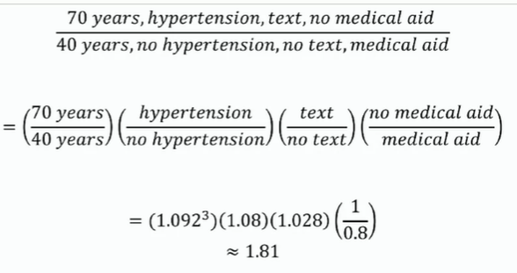

30 years age (OR) = 1.092^3

Hypertension to no hypertension = 1.08/1(reference)

Text to no text = 1.028 / 1(Reference)

No medical aid to medical aid = 1 (reference) / 0.8

**Investigating if receiving medical aid modifies the association of receiving a text reminder on showing up for a scheduled appt**

* Adjusted for age, hypertension and diabetes

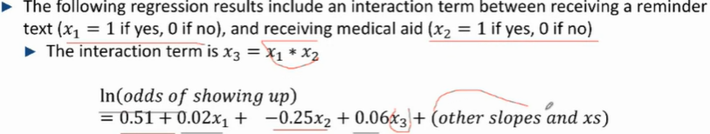

As we’re investigating how receiving / not receiving medical aid modifies the effect that receiving a text has on attending their appointments, the interaction term for receiving or not receiving medical aid ultimately serves to “modify” the slope for receiving a text

No medical aid,

X2 = 0, X3 =0

Ln(odds) = 0.51 + 0.02X1

OR^text v no text = 1.02

For individuals who didn’t receive medical aid, individuals who received a text message had 2% higher odds of going for their appointments

For those who received medical aid,

X2 = 1, X3 = X2*X1

Ln(odds) = 0.51 + 0.02(x1) – 0.25X2 + 0.06(1)(x1)

= 0.51 +-0.025 + (0.02 + 0.06)X1

OR^ text v no text = e^(slope for text ) = e^(0.02+0.06) = 1.08

Thus, for individuals who received medical aid, individuals who received a text message had a 8% higher odds of going for their appointments as compared to those who didn’t receive a text message

*We can see how the effect modification (by receiving medical aid) Changes how individuals respond to receiving texts i.e. receiving texts was more effective in those who received medical aid as compared to those who didn’t*

# Multiple Cox Regression

-Slope: measures the adjusted r/s between the **time-to-event** otcome and each predictor (x) in the model: djusted for other predictors (xs) in the model, at all times

-Slopes can be exponentiated to estimate HR^

-Unadjusted and adjusted hazard ratios (or slopes) can be compared to assess the present of confounding

-**intercept: ln (lambda^0, t)** is the base ln (hazard) of an event happening across all times t, given all slopes (xs) = 0

-**LHS =** 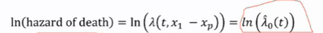

e.g. PBC trial dpca placebo

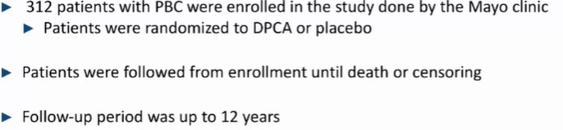

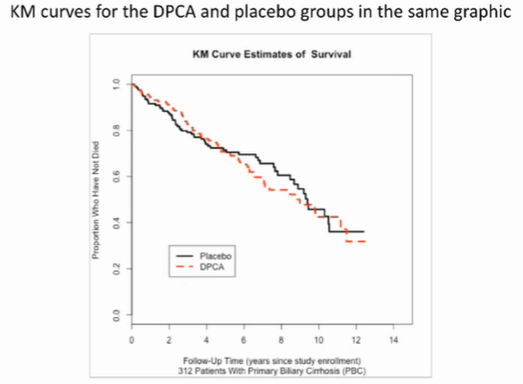

-The unadjusted ratio of mortality (and 95% CI) for the DPCA groups compared to the placebo group is 1.06 (0.75, 1.50)

- This crude hazard ratio is not expected to be confoundedby patient characteristics as it **was a randomised trial**

-However, effect modification is possible

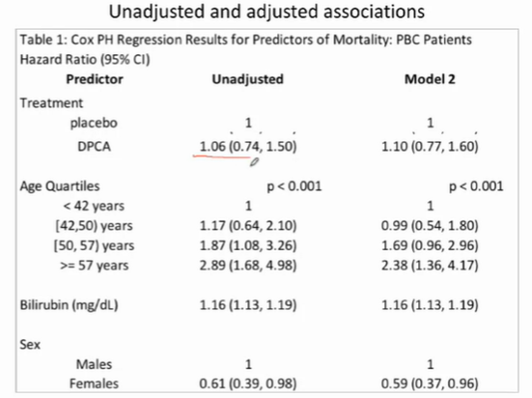

* HR^ for treatment, both adjusted and unadjusted, aren’t statistically significant
* Bilirubin and sex were both a predictor of mortality (before and after adjustment
* Relative mortality between different age groups still increase with an increase in age, though these increases do decrease in scale. however their CIs overlap, indicating that there’s no significant difference between age and mortality before and after adjustment showing that there was no or little confounding the risk of mortality depending on age
* The r/s between mortality and treatment was not confounded by age, sex or bilirubin as the HR^remained negative and statistically insignificant both before and after adjustment
* Age, sex and bilirubin were statistically significant predictors of mortality in both adjusted and unadjusted comparisons – with associations very similar in magnitude to the unadjusted associations

Example -- infant mortality and treatment

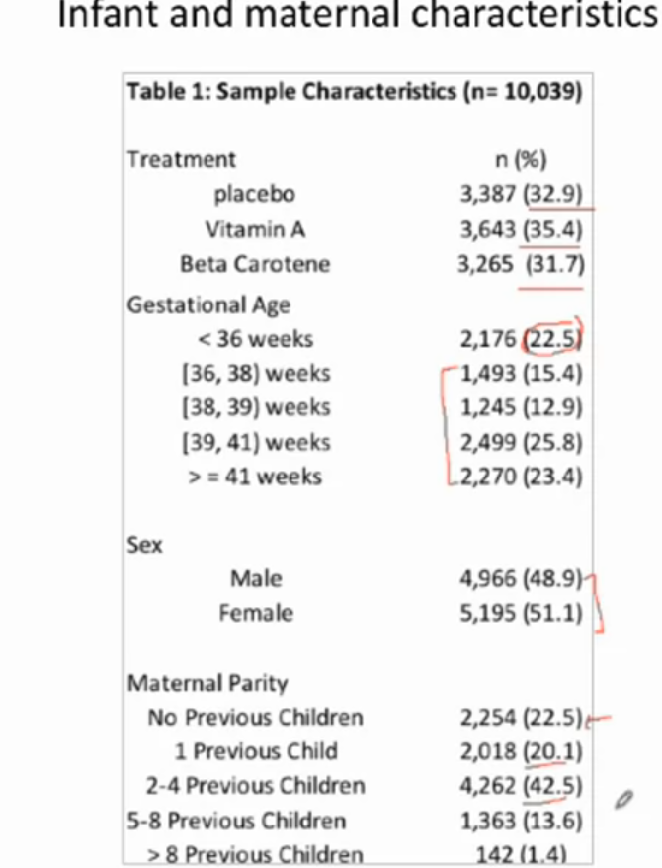

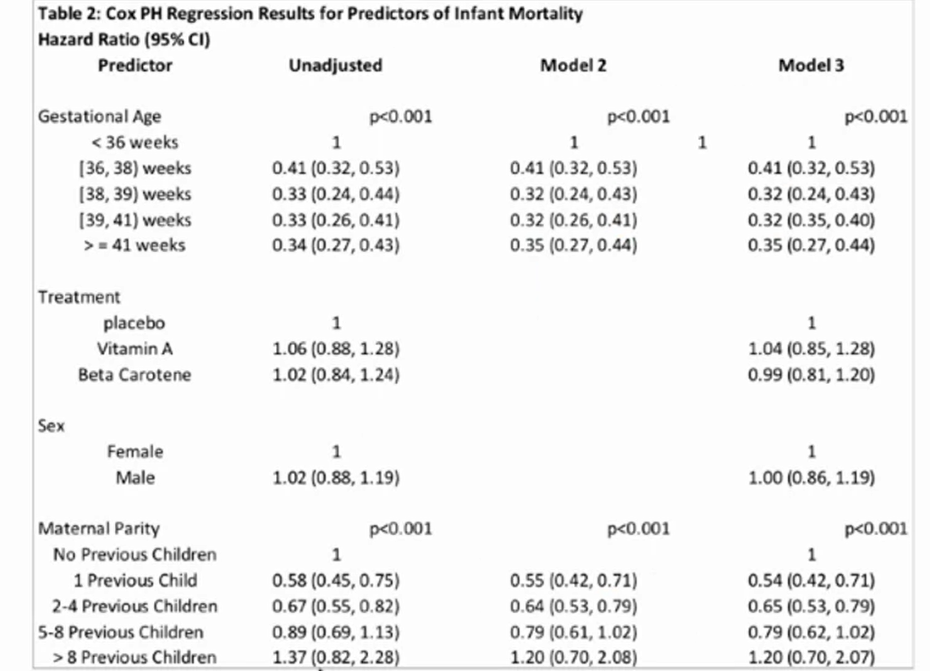

-in the simple cox regression, gestational age was a statistically significant term affecting nfant mortality; statistical significance remained when adjusting for treatment, sex and maternal parity or only maternal parity. However, the hazard of infant morality only decreased significantly going from <36 weeks to 36weeks – 38 weeks and stayed relatively constant from then on

-treatment was not statistically signiciant in both adjusted and unadjusted comparisons (no confounding expected given that the trial was randomised)

-Sex was not statistically significant in both adjusted and unadjusted comparisons comparisons (no confounding expected given that the trial was randomised)

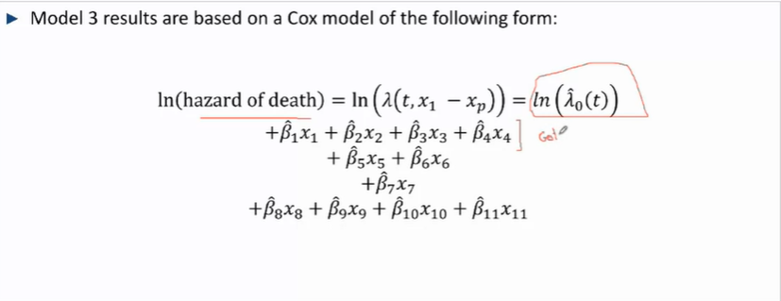

The subscripts represent the following:***each slope represents the ln HR^ of the variable with reference to the reference group***

1-4 gestational age categoreies (with reference to <36 weeks)

5-6 Treatment

7 sex

8-11 Child parity categories

-of the 4 predictors considered, only gestational age and maternal parity were statistically significantly associated with infant morality

-There was no indication that the r/s between mortality and gestational age was confounded by maternal parity, nor the r/s between morality and maternal partiy was confounded by gestational age – after adjusting for gestational age and maternal parity given the Estimated HR^s and Cis were extremely similar

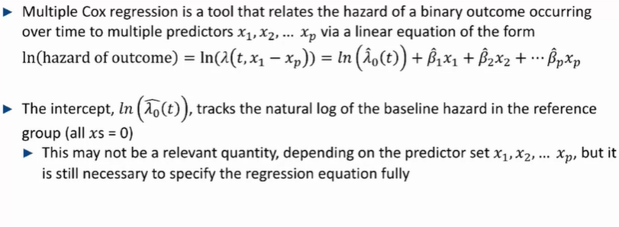

## Model estimation and uncertainty for multiple cox regression models

### Partial Maximum Likelihood – estimating a cox regression (slopes and intercept)

To estimate a cox regression, we use **partial maximum likelihood**

* The estimates for slopes B^1 – B^p are values that maximisese the likelihood of the **given dataset** given the slopes
* The slopes are estimated after the baeline hazard function lambda^0 (t) is estimated via another process
* As such all regression slope estimates, **based on a single given dataset**, have an associated SE^ that can be used to make statements about the true rs between ln(hazard that y=1) and x1-xp – standard error estimates, inferences can be made only for the **given dataset (sample)**
* Random sampling behaviour of regression slopes are approximately normal (taking this 1 dataset as a possible dataset out of all the possible datasets ) around the unknown truth
  + Thus we have to calculate the 95% CI of the slope to ascertain where the likely “true” slope will fall within
  + Slope = Ln(hazard ratio) are estimates in large samples – can be adjusted for smaller samples using t-tests etc.
  + E^slope = HR^
* TO measure the statistical significance of the slope,
  + Assume H0: HR = 1 and slope = 0, if p <0.05 for H0, we can reject the null and conclude that our slopes are statistically significant

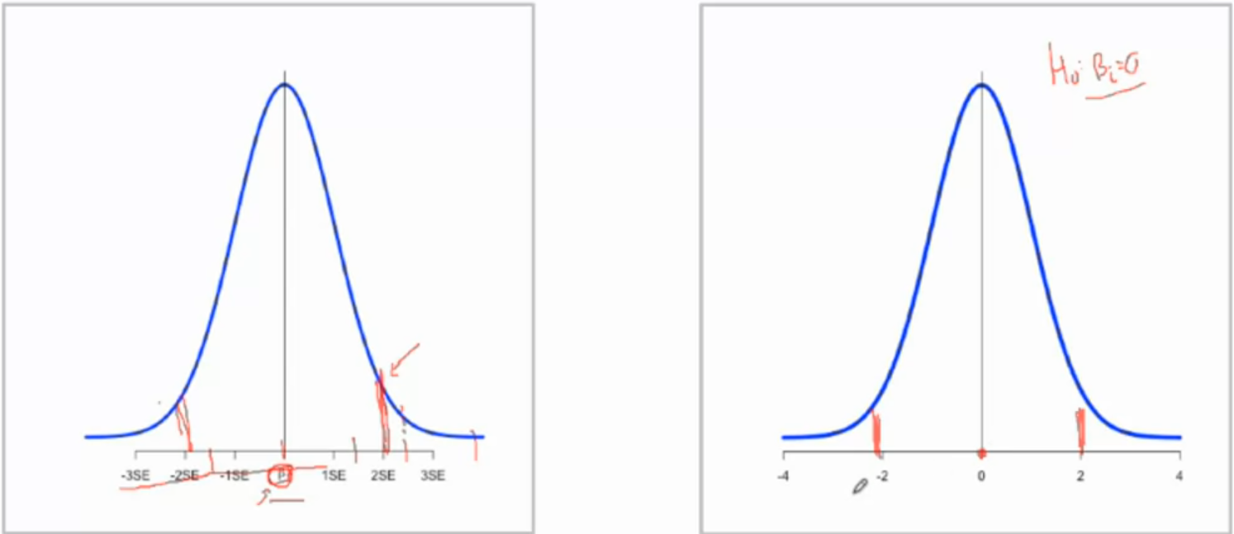

**Intercept** – function of time: gives the base value for all xs =0 at each point in time

-Unceratinty estimates for the intercept are estimated and used for putting Cis on predicted survival curves based on the cox results

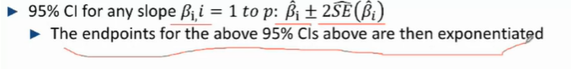

**Testing population slopes**

Bi , I = 1 to p

This tests whether xi (each slope) is a statistically significant predictor of y after accounting for the other xs in the model

H0: Bi = 0 vs Ha: Bi =/= 0

Assuming the null is true Bi = 0,

Z = B^/Se(B^)

Example – DPCA and liver cirrhosis

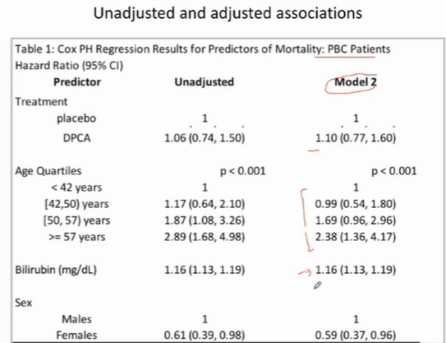

Taking the ln of each of the adjusted HRs in model 2

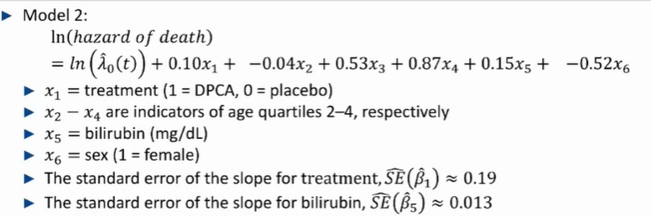

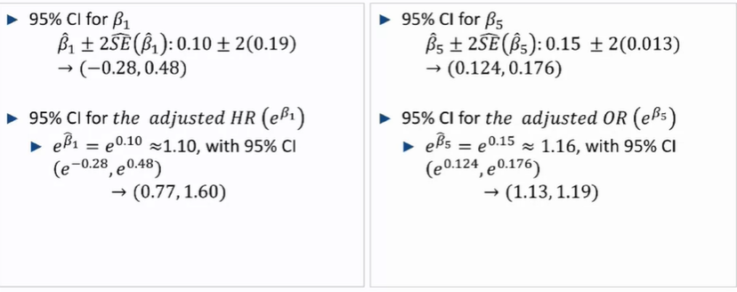

* The slope for treatment, contains the null value = 0, thus we can conclude that treatment administered (be it a placebo or DPCA) is a statistically significant predictor of mortality after adjusting for age, sexand billirubin
* 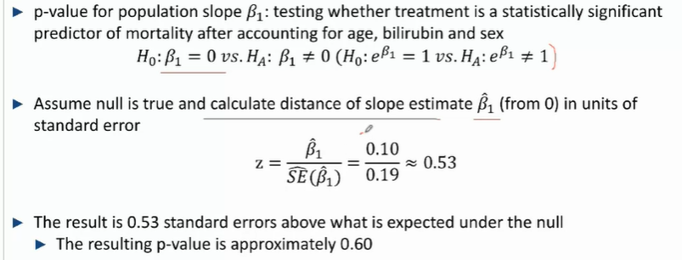

### Likelihood ratio test – Testing multiple slopes (for statistical significance) in a multiple cox regression

* When a predictor is multi-categorical and modelled with multiple xs, in order to test whether the predictor,

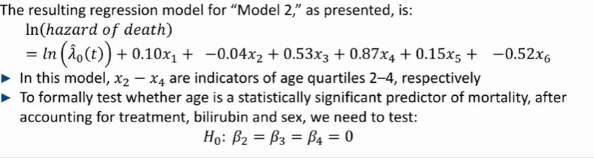

H0: B2 = B3 = B4 = 0 so we can see the differences between the non-reference categories themselves

**Likelihood Ratio Test (LRT), LRT**-Compares the amount of info about mortality explained by treatment, age bilirubin and sex as compared to the amount of info explained by the same minus age (bilirubin and sex only)

Extended vs null model: (Null model is nested in the extdended



**Likelihood ratio test (LRT):**

H0: all slopes for the additional predictors in the extended model = 0

Ha : not all slopes for the additional predictors = 0 (there is extra information provided by the extended model not provided by the null model

## Estimating HRs for groups who differ in more than 1 predictor with multiple Cox Regression

Example – DPCA and multiple-liver cirrhosis

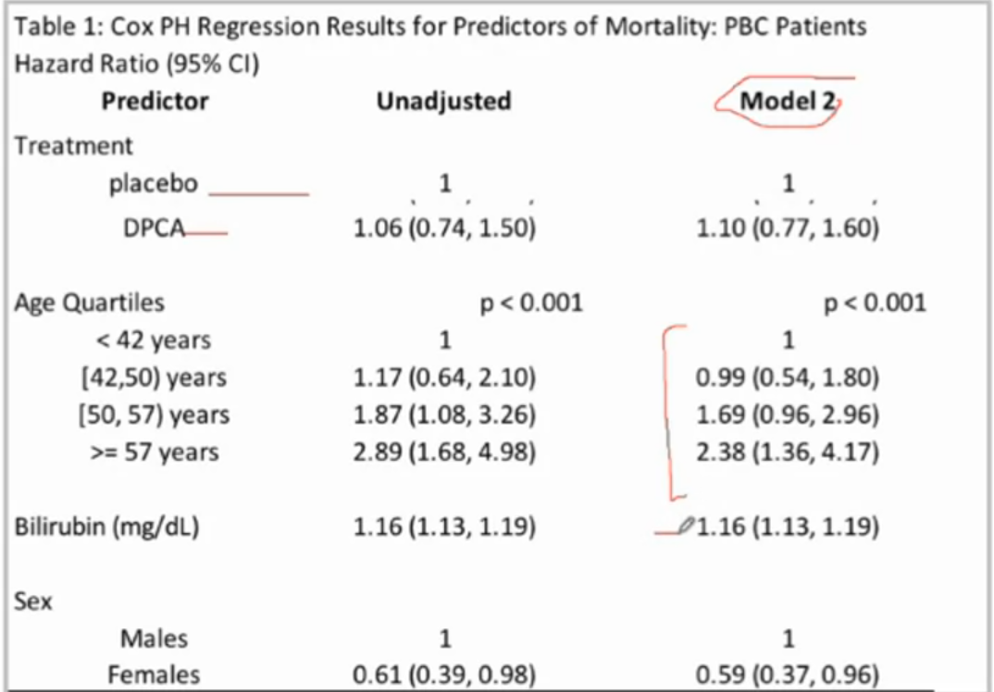

Taking the ln of each of the adjusted HRs, you get the slopes

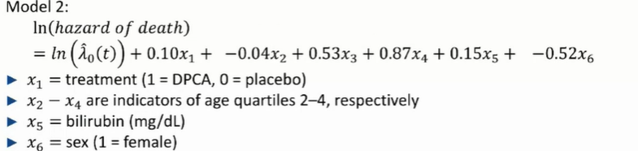



-sub in 1/0 when appropriate for binary and categorical variablse (treatment, age, sex) and the continuous variables when required (bilirubin)

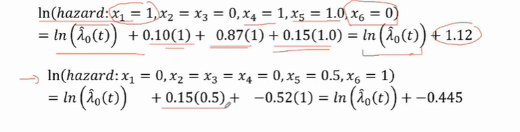

Difference in their ln (Hazard) i.e. their ln (HR^) is 1.12 – (-0.445)

Ln(HR^) = 1.565

HR^= e^1.565 = 4.78

Sixty-year-old males on dpca with bilirubin = 1.0mg/dL have 4.78 times the hazard of mortality when compared to 40 y/o females on placebo with bilirubin = 0.5 mg/dL (at any time in the follow-up period)

* 95% Cis can be calculated for the difference with a computer

HR can be calculated with the Hazard ratios or the ln(HR^)

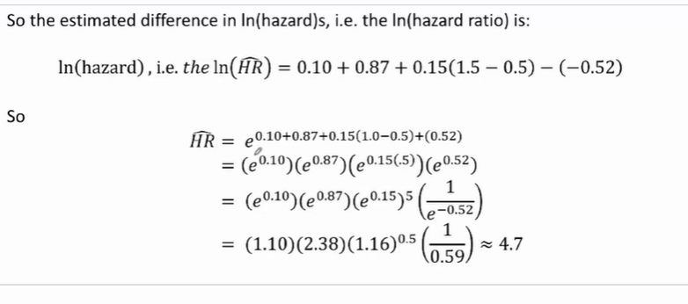

Using the ln(HR^): HR = e^(lnHR^)­­­­1 * e^(lnHR^)­­­­2 * e^(lnHR^)­­­­3 ......

Using the HRs themselves Hr overall = HR1 * HR2 * HR3 …

Where subscripts 1, 2, 3… represent the terms of comparison respectively

For example , comparing the hazard ratio of

**Male** children who are born **preterm(< 36weeks)**, whose mothers are given **vit A** and have had **5 previous children**

Against

**Female** children who are born at **40 weeks of gestation,** whose mothers are given **beta-carotene** and have had **no previous children**

** we can multiply the hazard ratios between the 2 groups for each term of comparison to get the overall HR

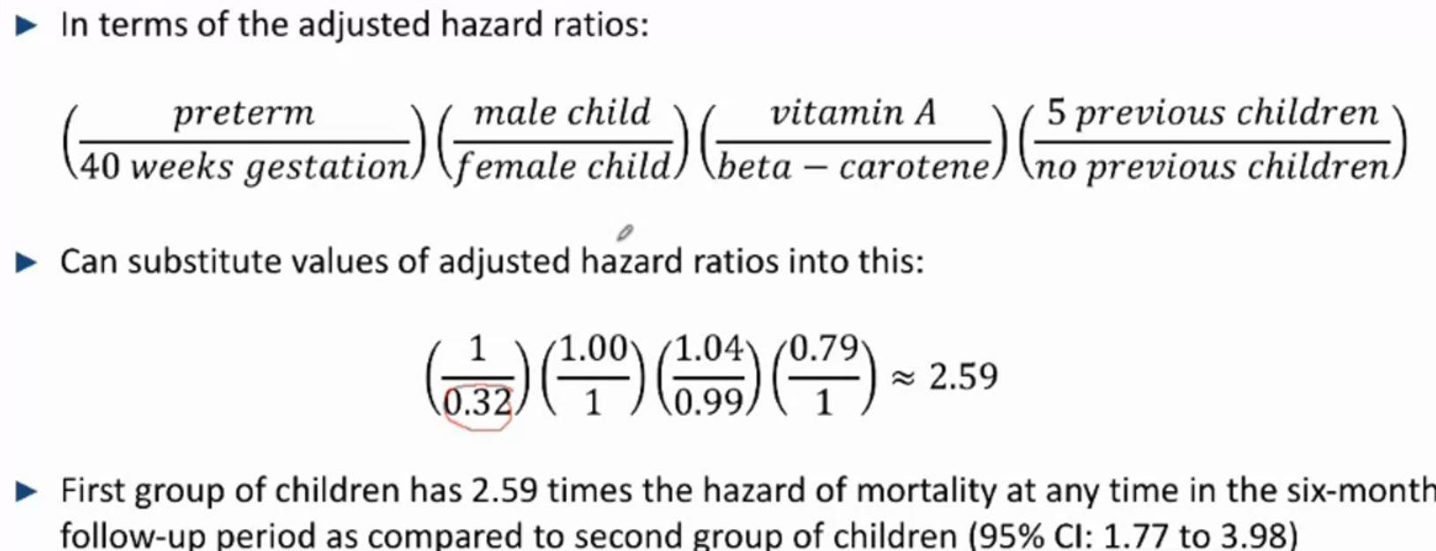

Provided we are provided with the adjusted HR data below

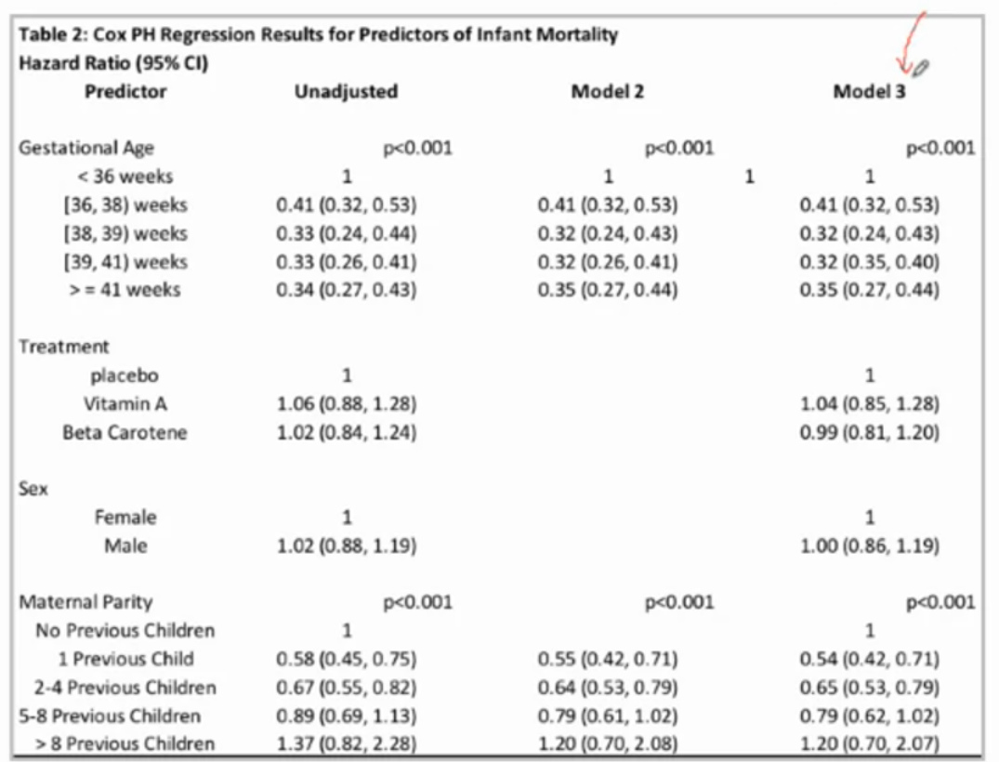

**Summary**

* Results from multiple cox regression can be used to estimate the HRs and compare the hazard of an outcome of interest between groups who differ by more than 1 predictor
  + This can be computed by multiplying the Hazard ratios (adjusted, on the linear scale) or exponentiating the sum of the slopes (ln HRs, on the log scale)
* Cis can be computed with the aid of a computer

## Linearity assumption and predicting with the multiple cox regression

e.g. PBC, primary biliary cirrhosis

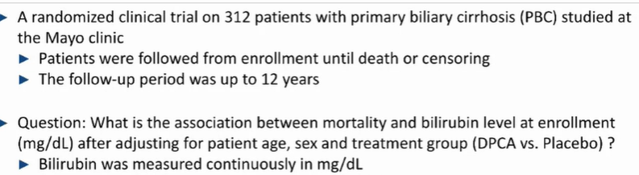

*But, does the model and prediction hold when bilirubin is continuous (i.e. is it necessarily linear)*

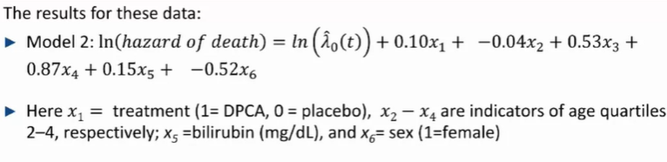the slope of bilirubin levels, B^5 = 0.15 – for each increase of 1mg/dL in bilirubin levels, the ln(hazard of death) increases by 0.15

### Assessing the linearity assumption for a single predictor

**How do we asses whether the linearity assumption is reasonable?**

* No easy visual tool like a lowess plot
* We use an empirial approach: categorise a continuous predictor into groups and ssee if the diff in ln(hazard) between continuous groups remain roughly constant

Splitting bilirubin into quartiles, predictors x5 to x7

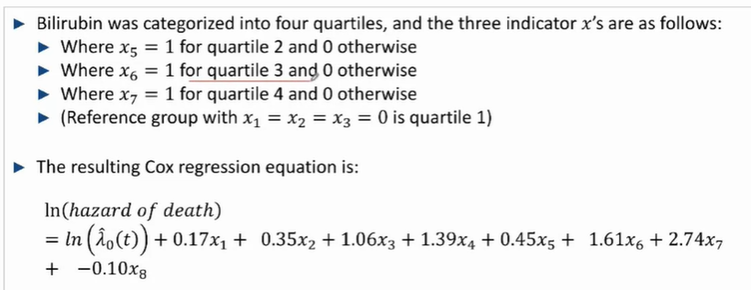

-the differences between the slopes of the bilirubin quartile 1 and 2 = 0.45, 2 and 3 = 1.16 and that between 3 and 4 = 1.13.

Thus the difference in ln (hazard) from quartiles 2 to 4 remain relatively constant but they are both larger than the ln(hazard) ratio increase from quartile 1 to 2.

*Thus, a linear assumption may be overestimating the initial increase in ln(hazard of death) for low levels of bilirubin – although it captures the general idea*

### Choosing the best multiple cox regression model

* Depedns on the goal of the research

1. To maximise precision of adjusted estimates: keep only the predicors that are statistically significant in the final mode
2. To present results comparable to results of similar analyses: include all predictors that were present in the previous study
3. To show what happens to magnitude of association for different levels of adjustment: present the results from several models that include different combinations of adjustment variables

### Cross validation Prediction – Estimating survival curves

-Models for prediction should always be evaluated against data that is different from what it was built with

-for a given dataset, split it **randomly** into 2, use 1 for testing and 1 for “training”

-Use computers to estimate several specific values of X1 to Xp

**Math part – how to compute the different curves**

* Basically, compute the cumulative hazard incurred up through time t (integration) 🡪 convert this to survival / risk itself 🡪 plot the risk/survival for each time interval

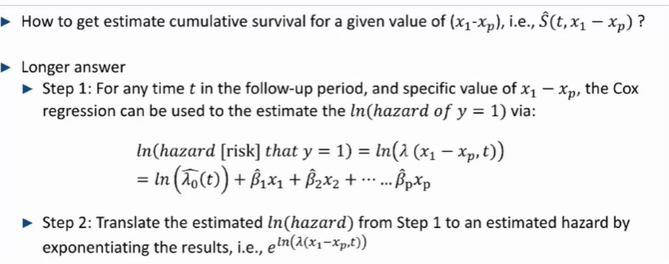

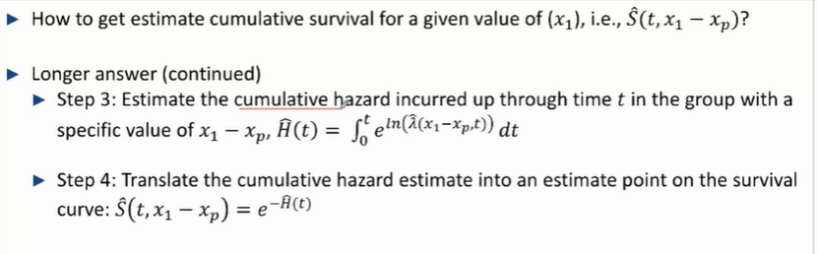

E.g. different survival curves for females of low and high bilirubin respectively (across diff ages)

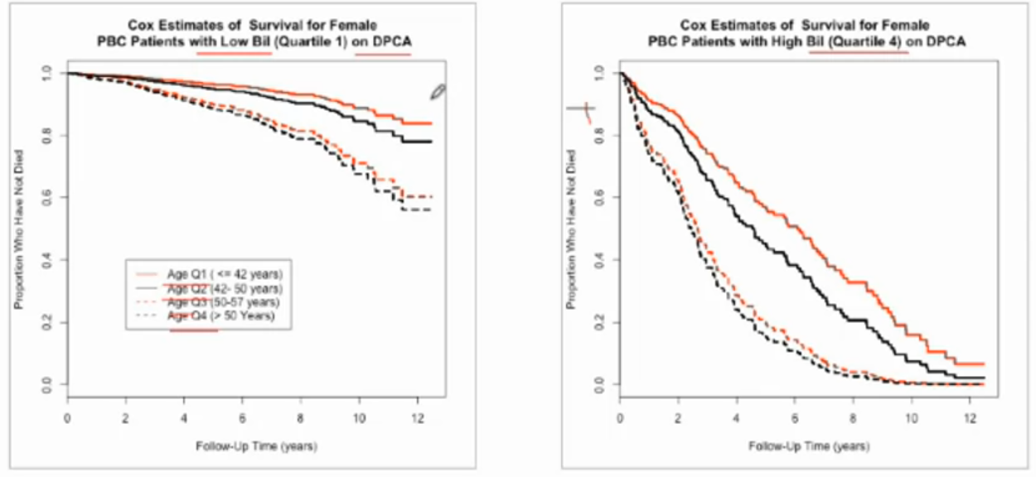

-Indiviuals with low bilirubin (q1) had much higher rates of survival with increasing time as compared to individuals with high bilirubin (q4), across all age groups

### Confidence intervals and uncertainty for survival curves

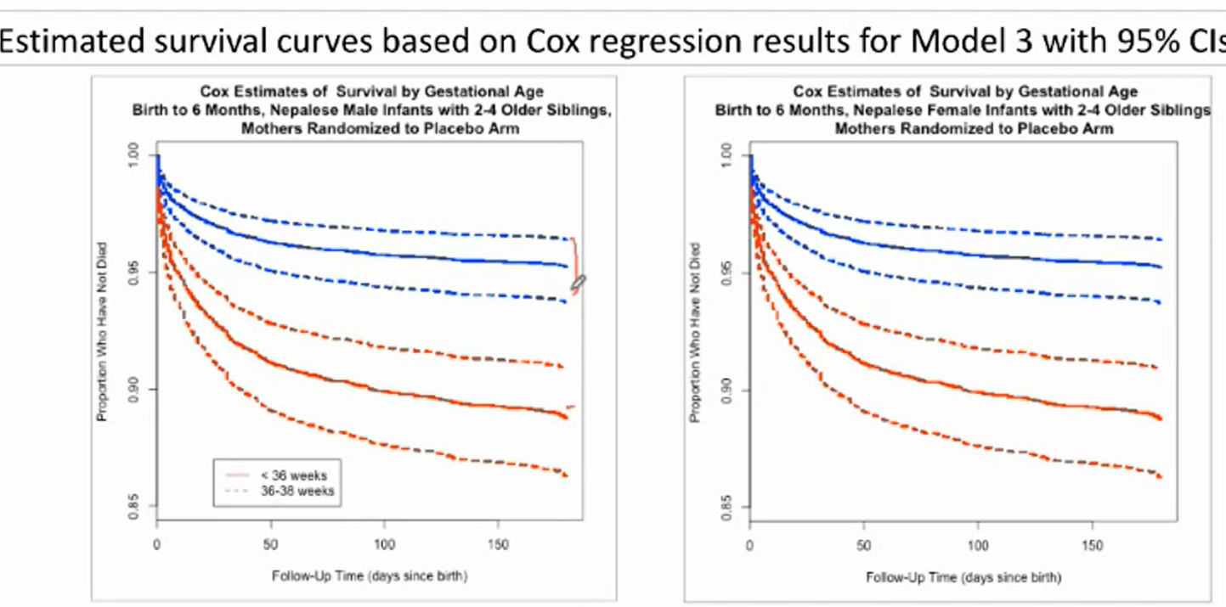

* The uncertainty in the curves arises from uncertainty in:
  + The intercept estimate, ln(lambda^0,t)
  + The slopes Xi, where i = 1to p (p being the last variable)

**Summary**

* Including continuous predictors in a multiple cox regressin model assumes that there is linearity between the ln(hazard) and predictor 🡪 this needs to be evaluated through categorisation (ascertain that the difference between slioes if successive categories should be relatively similar – including that of the reference category and the first)